](https://youtu.be/2dWB76-w-r8)

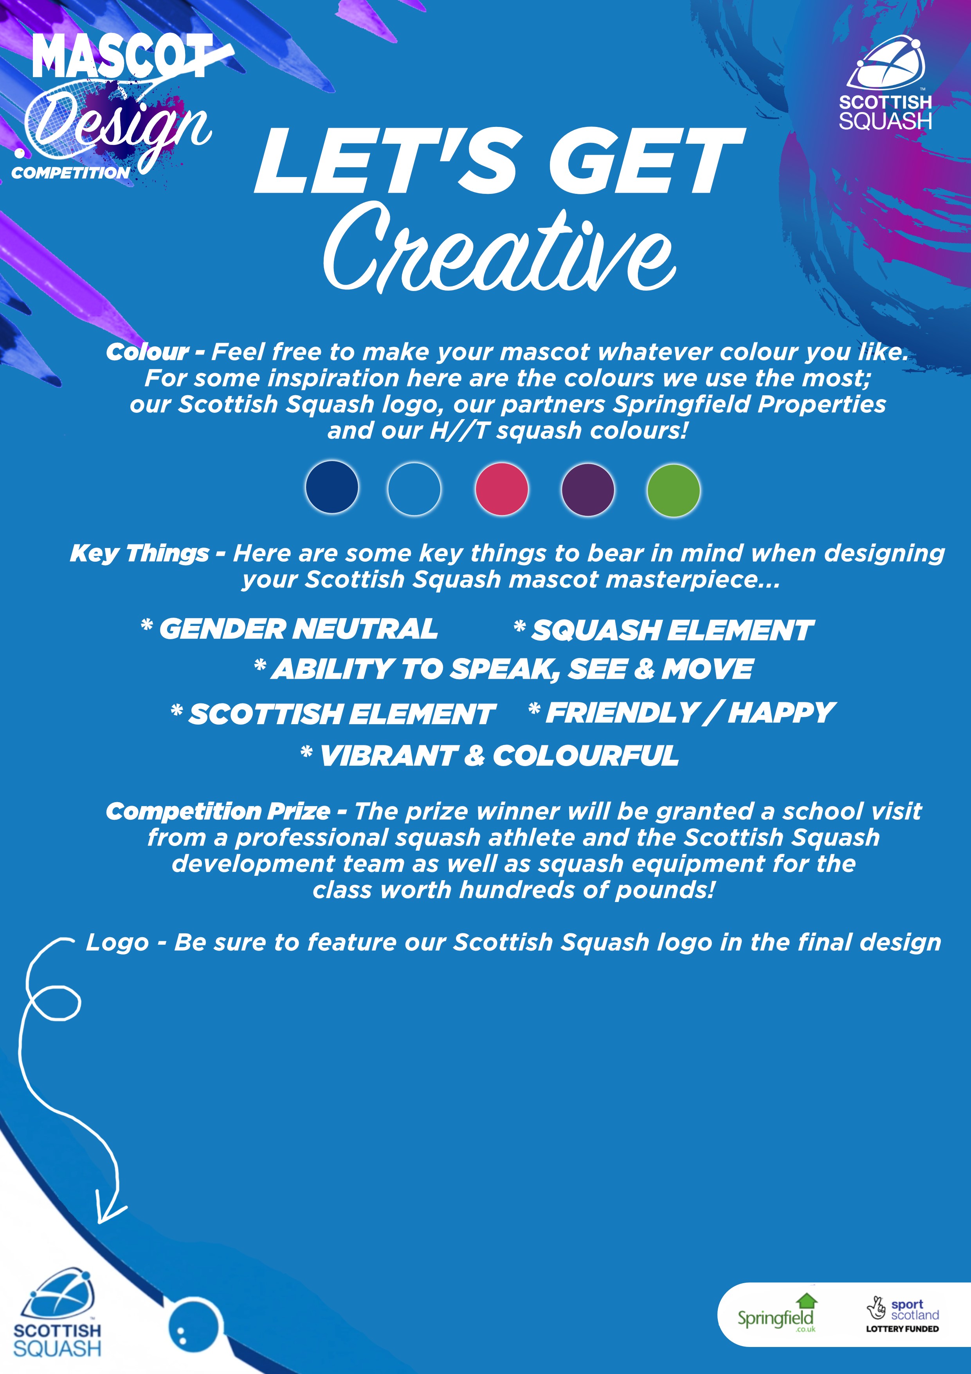

I have read & agreed to the competition terms and conditions listed in the pack, YES or NO:

School Phone No:

School Email:

School:

Age:

Name:

Mascot Back Story:

Mascot Name:

