SportyHQ User Guides September 2018
Tournament User Guide 2
How to run your tournament using SportyHQ

Version Control
Version No. | Date Amended | Amended By | Reason
1.0 | 14.09.2018
TABLE OF CONTENTS
How to run your tournament using SportyHQ
- How to use SportyHQ ………………………………………………………………………………………3
- Changing a Scheduled Match……………………………………………………………………………6
- Printing Scoresheets……………..………………………………………………………………………….7
- Printing Draws………………………………………………………………………………………………….8
- Displays…………..……………………………………………………………………………………………….9

- How to use SportyHQ to run your tournament
Login to SportyHQ and select the event you are running from the column on the left-hand side navigation bar. If you are an administrator for this event it should automatically appear here.

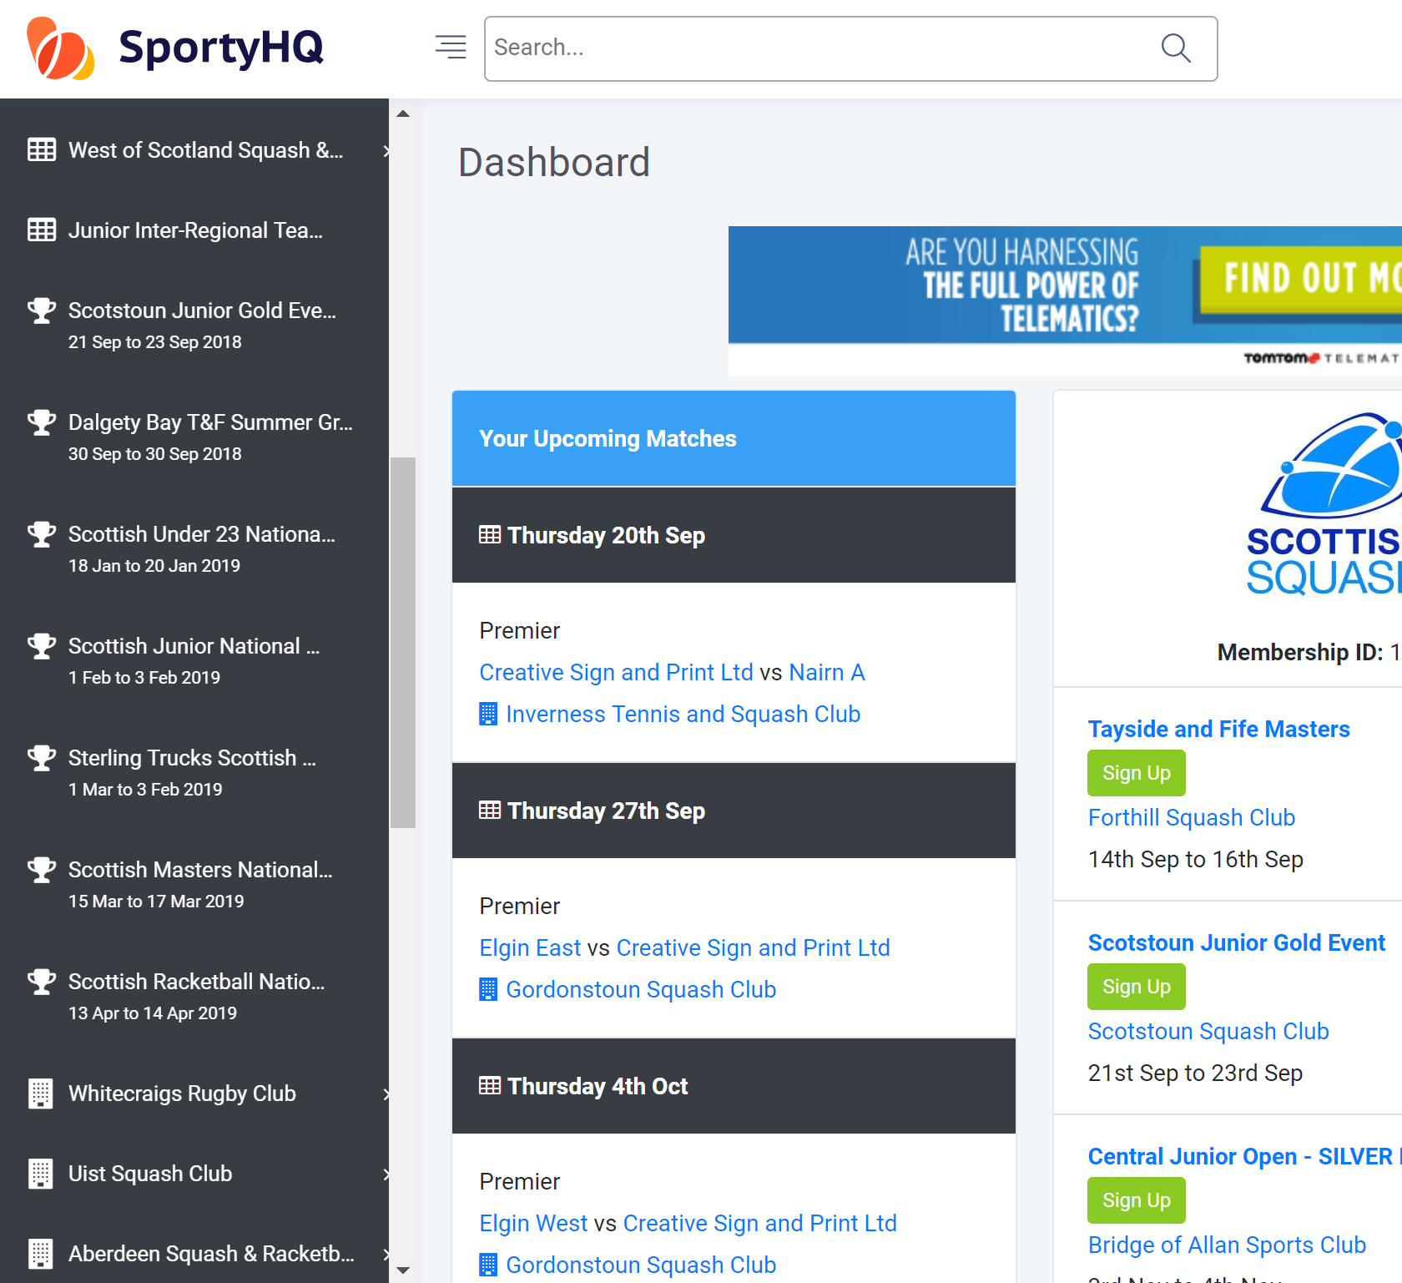

The event page will open in the below format. The secondary navigation menu will appear down the left-hand side. This provides organisers with all the administration settings when you organise event. The main section required to run the competition on the event days is the Resources section (see red box below).
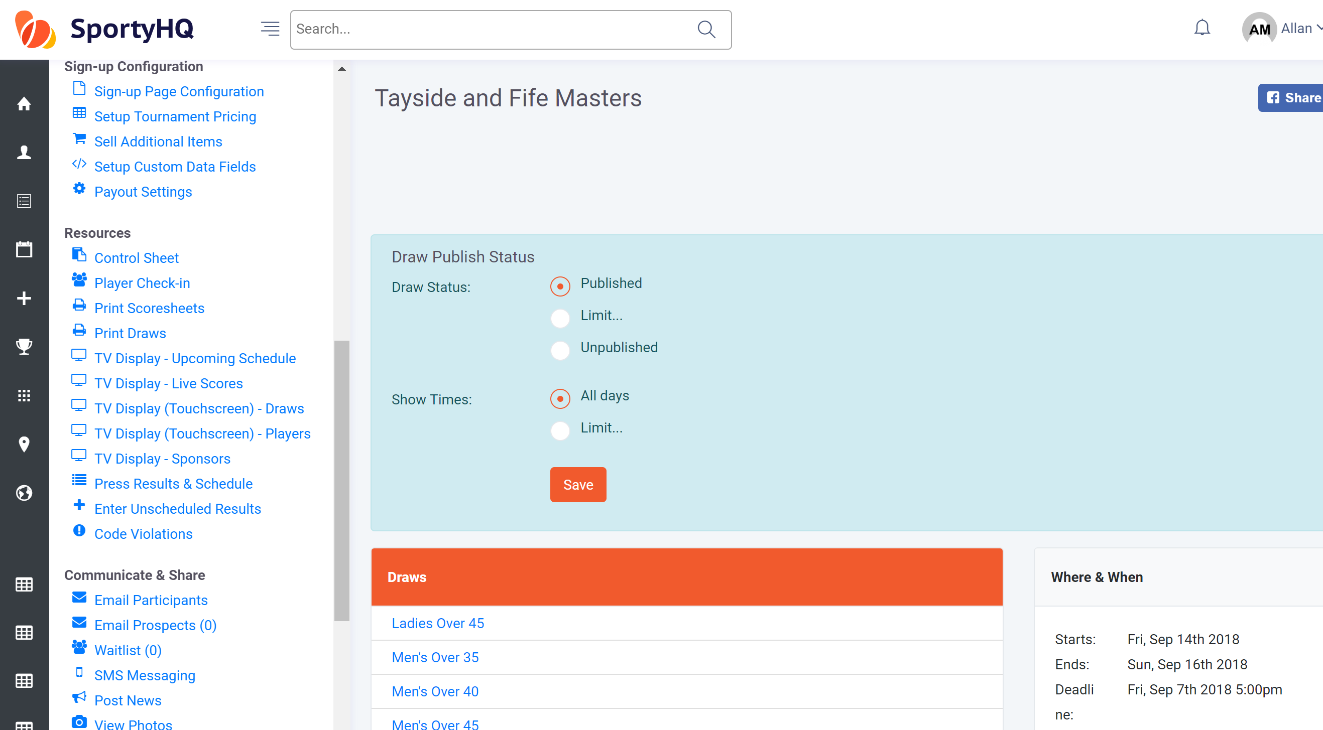

Within this you have a Player Check-in function which you can use to sign players in. There is also the function to print this list off if you would rather.

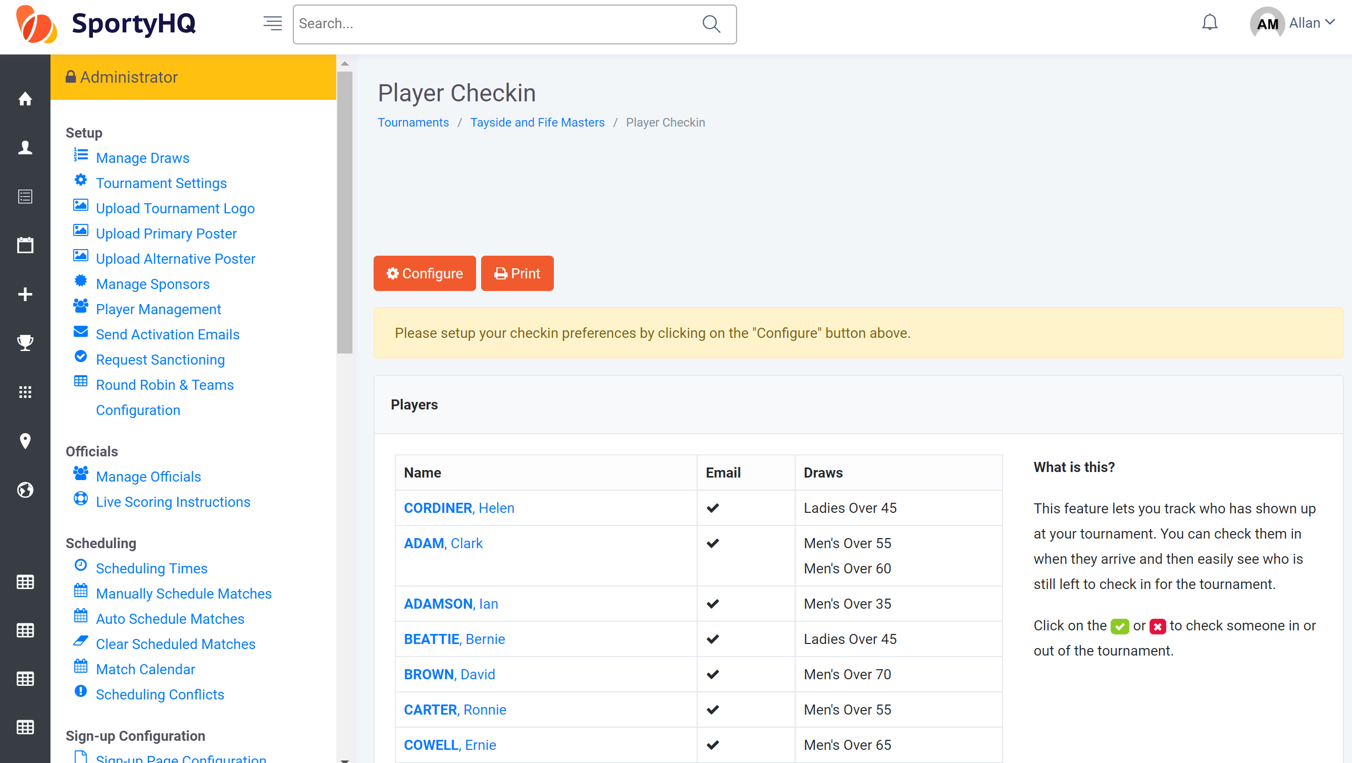

Once your event has started and you wish to enter results you need to select the Control Sheet, again this can be found under the Tournament Resources column. This Control Sheet can be seen in two formats. See below:

Function 1 – shows matches listed Function 2 – shows matches listed
under their court under scheduled time
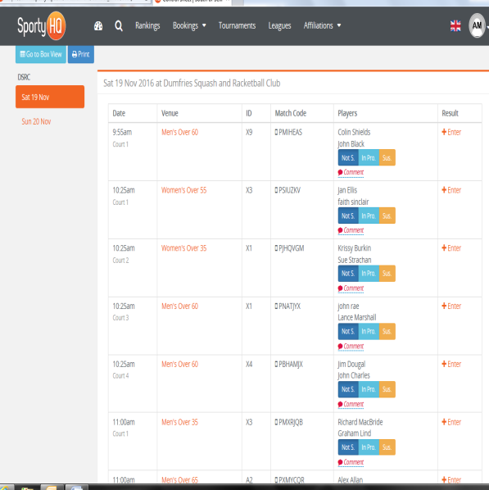
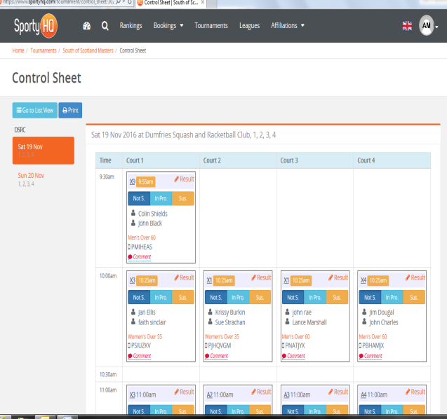
The view between the court list and time list can be changed by clicking on the blue button, Go to Box View or Go to List View depending what setting you are on. The system will default to box view.

To enter a result, click on Result or Enter under the result column. It will then open with the following window where the result can be entered.

- Changing a Scheduled Match
As a Tournament Organiser you have the ability to change match times or move matches around as and when required. All match times and the weekend schedule can be changed in the Match Calendar tab under the Scheduling section of the administrator panel.
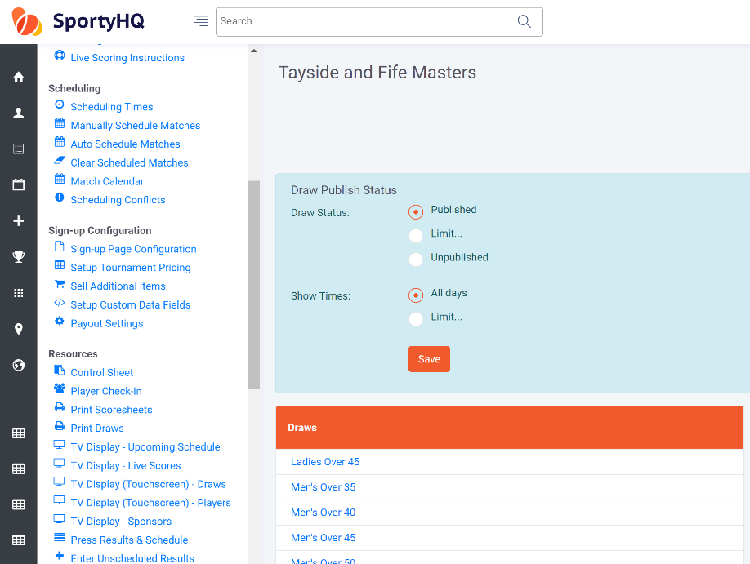

Once you open the ‘Match Calendar’ it will show the following window.
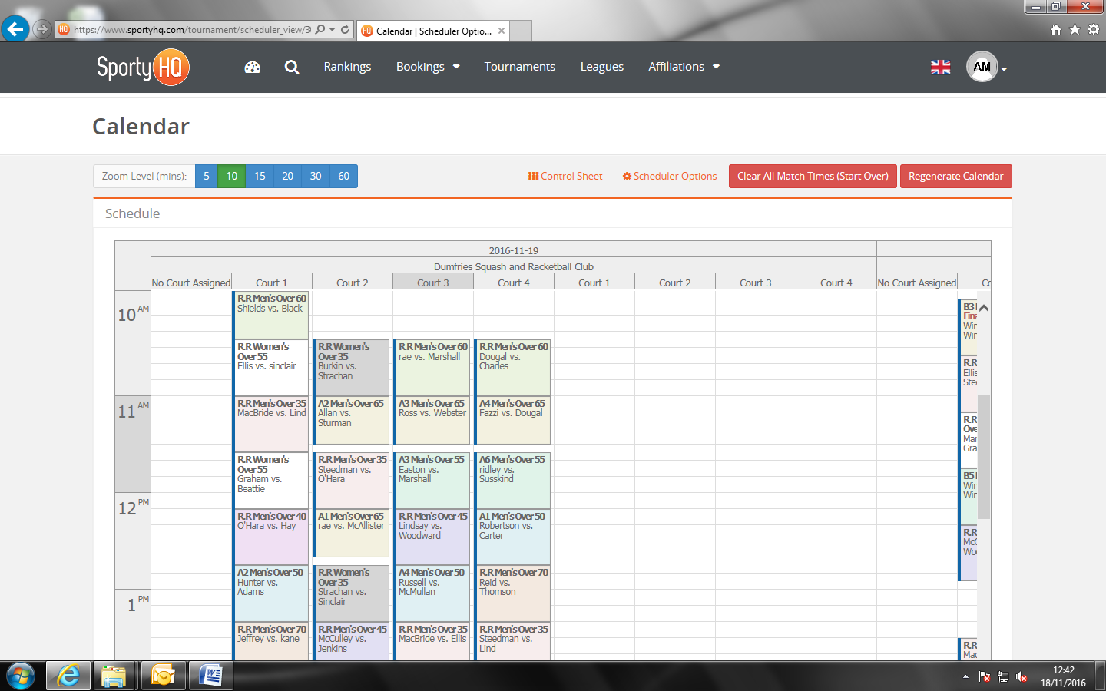

By clicking on any of the matches you are able to move them around to different times, between different courts and even to different days.

- Printing Scoresheets
The software can print of each specific scoresheet for every match scheduled in the competition. When this function is used the scoresheet will automatically populate the competing players, court number, scheduled time and draw category. To print the scoresheets from the software click on Print Scoresheets under the Resources section on the administrator panel.
When you click on Print Scoresheets you will also notice the option to Print a Blank Scoresheet. If you would like a scoresheet template with no names included you should use this option.

- Print Draws
Event draws can be printed off at any point and will automatically be updating depending on the results you have entered to the Control Panel.

- Displays
The software is compatible with many display options when running your tournament. If you can connect your tournament laptop to an addition monitor/screen it is really useful in the smooth organisation of the event. The software can offer the following display options:
- TV Display - Upcoming Schedule:
This lists upcoming matches and the court the match will take place on.
- TV Display – Live Scores:
If referees are making use of the SportyHQ ‘ScoreSquash’ mobile application to referee individual matches, the live score can be displayed on monitors.
- TV Display (Touchscreen) – Draws:
This saves the need for organisers to print out draws. Draws can be displayed on touch-screen monitors and individuals can come and select draws and zoom into certain rounds to keep up-to-date with live draws.
- TV Display (Touchscreen) – Players:
This displays a list of all players in the competition broken down in to the different categories.
- TV Display – Sponsors:
This displays all event sponsors that have been added to the SportyHQ event page.

