SportyHQ User Guides July 2018
Tournament User Guide 1
How to set-up a Tournament

Version Control
Version No. | Date Amended | Amended By | Reason
1.0 | 01.01.2018
2.0 | 09.07.2018 | Allan McKay | Update

TABLE OF CONTENTS
How to set-up a Tournament
- Administrator Access………………………………………………………………………………………3
- Creating a New Tournament…………………………………………………………………………..5
- Sanctioning Your Tournament………………………………………………………………………..14
- Adding the Extra Detail…………………………………………………………………………………..15
- Creating Draws……………………………………………………………………………………………….17
- Creating the Schedule…………………………………………………………………………………….22

- Administrator Access
Firstly, you need to gain administrator access to the appropriate club or regional SportyHQ page that you are running the competition for. For example, the West of Scotland Masters should be run through the West of Scotland Squash SportyHQ site whereas, a Junior Gold event hosted by Aberdeen Squash & Racketball Club (ASRC) should be run through the ASRC SportyHQ page.
To be given administrator rights to a certain page you should speak with your club or regional main contact or Scottish Squash (info@scottishsquash.org).
Once you have gained administrator access and are logged into SportyHQ you will notice it lists your clubs and/or regions down the left-hand menu. If you have administrator rights to your club when you click on the club you will notice a drop down menu expands and shows a Club Admin button (see blue box below). Click Club Admin to access the administrator page for the club. To access the administrator page of regional SportyHQ pages click on the regions name (see red box below).
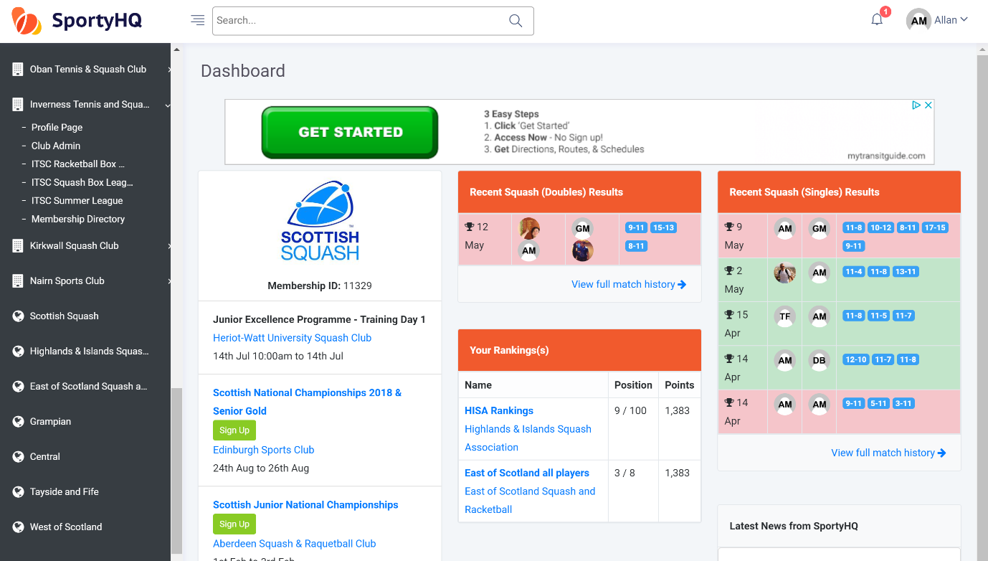
The layout of a club administrator page and regional administrator page are slightly different (see pictures below). However, the steps for setting up a tournament are very similar.

Club administrator page
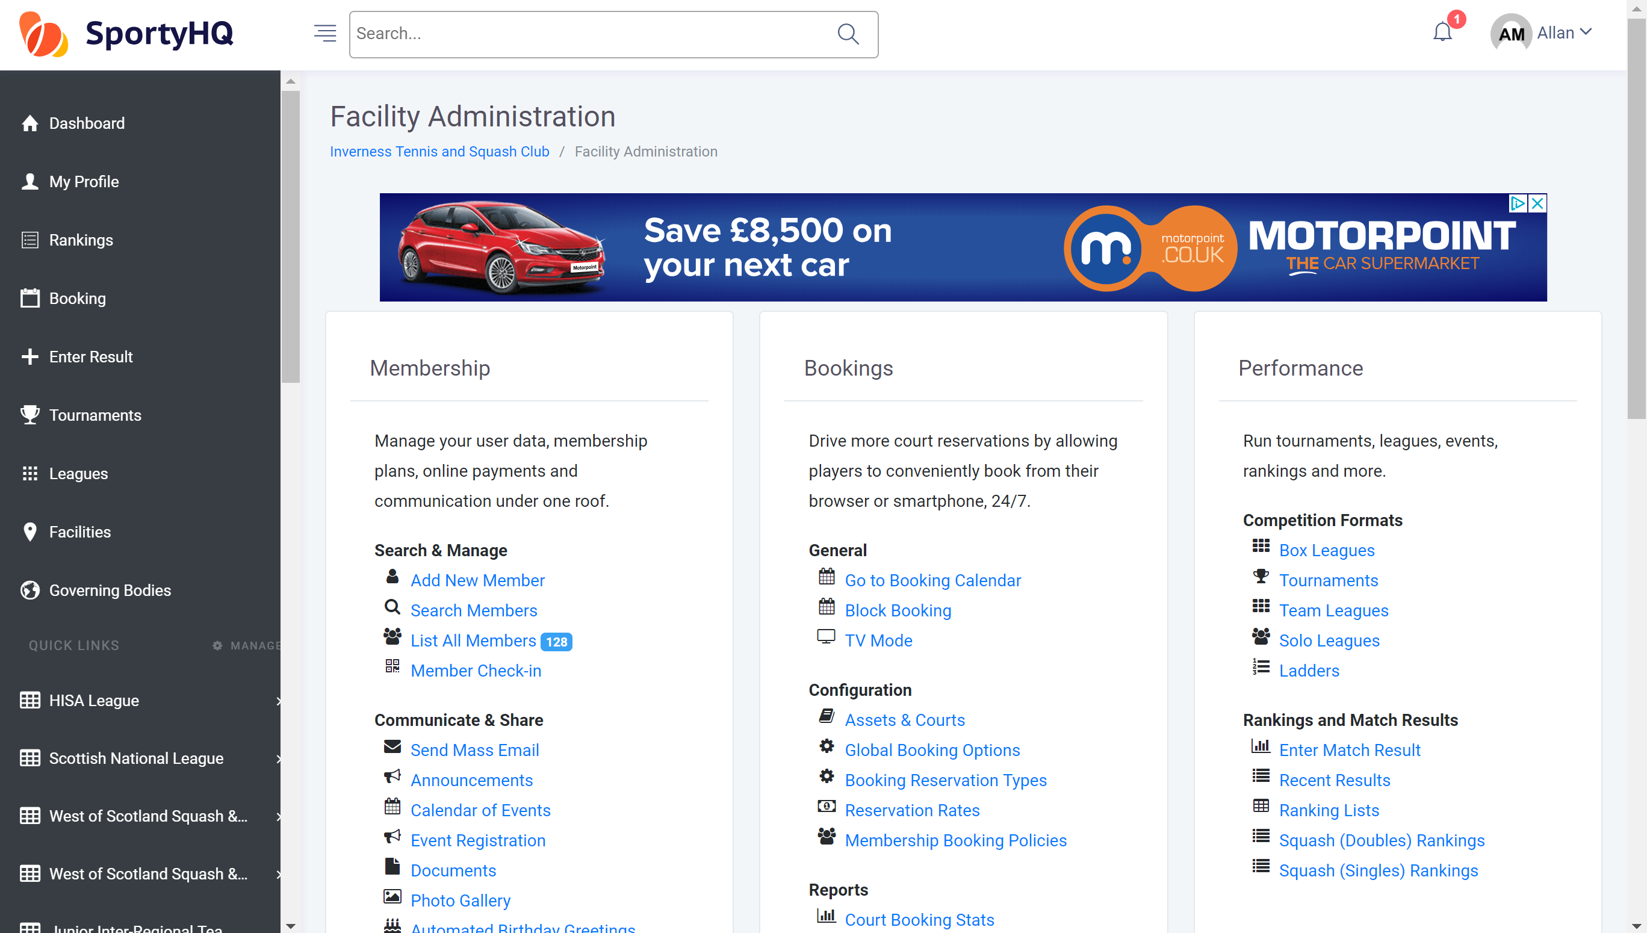
Regional administrator page
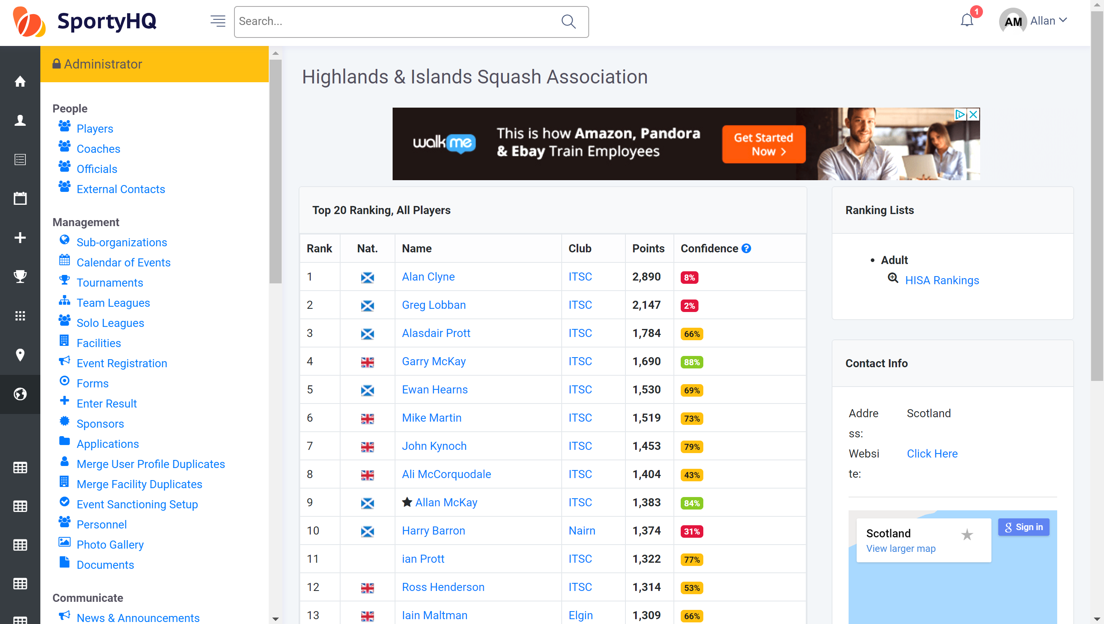

- Creating a New Tournament
From the club administrator page go to the Performance settings. Click on Tournaments -> Create Tournament and from the regional administrator page click on Tournaments -> Create Tournament.
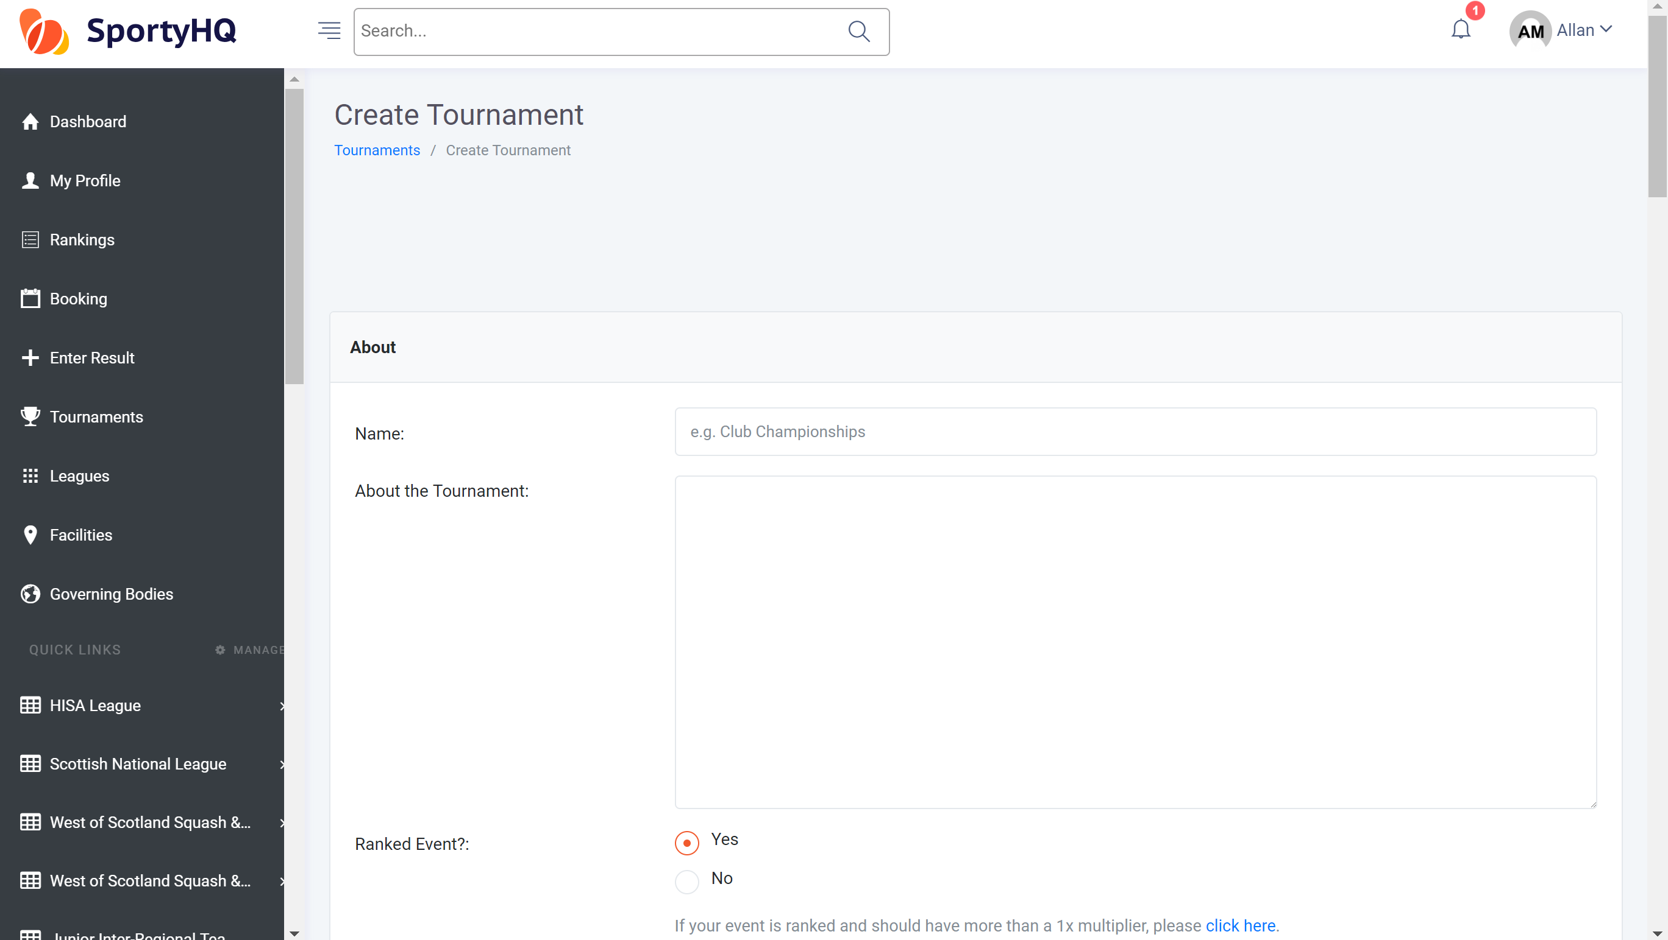
This will open a new window that looks for the basic information about your tournament. Follow the steps within this page to input the basic tournament information. If your tournament is a Scottish Squash sanctioned tournament you should tick Yes for the ‘Ranked Event?’ question.
‘Age Limit Cutoff Date’ – this links to tournaments where your age depends what event you can enter. For example, to enter the Scottish Junior Nationals under 19 event you must be aged 18 or younger. To activate this setting, you would put the date when you must still be under the age by. For example, squash tournaments normally state that you must be under the age on the last day of the event.
‘Sign Up Preference’ – If your tournament is a Scottish Squash sanctioned tournament you should tick Use SportyHQ (Recommended) box here.
‘Registration Deadline’ – For Scottish Squash events the closing date is normally set as 2 weeks before the start of the competition. This gives plenty time to confirm arrangements, seeds, draws and schedule.
Once you have completed this page click Submit.

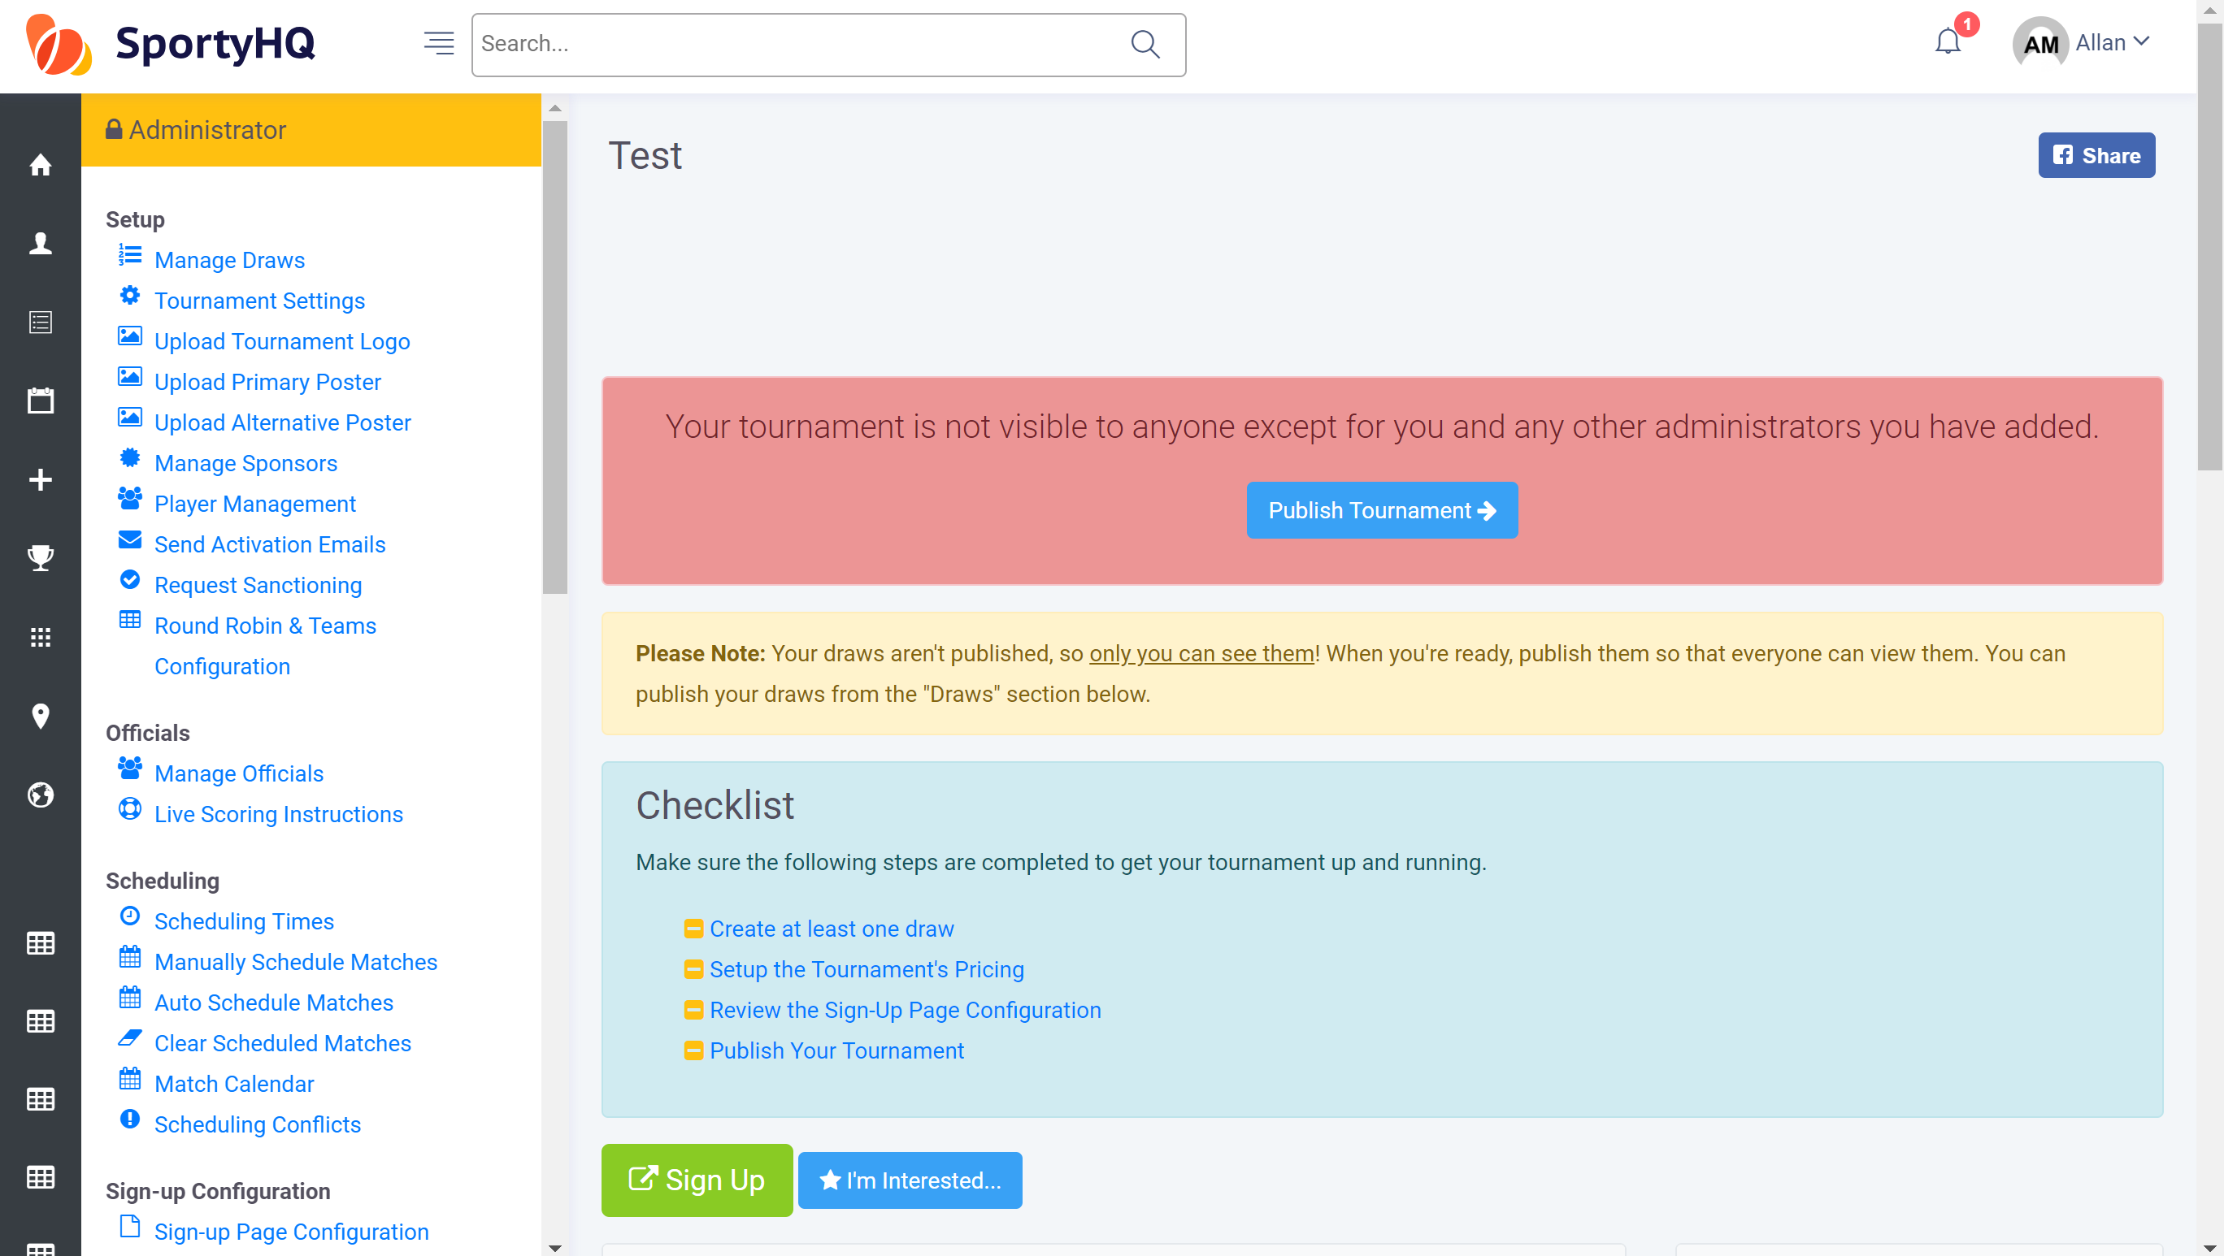
Once you have clicked Submit it will create your tournament page and the above window will open. Please note that at this stage nothing is live and no one can see the tournament. This will be the case all the way through until you Publish Your Tournament.
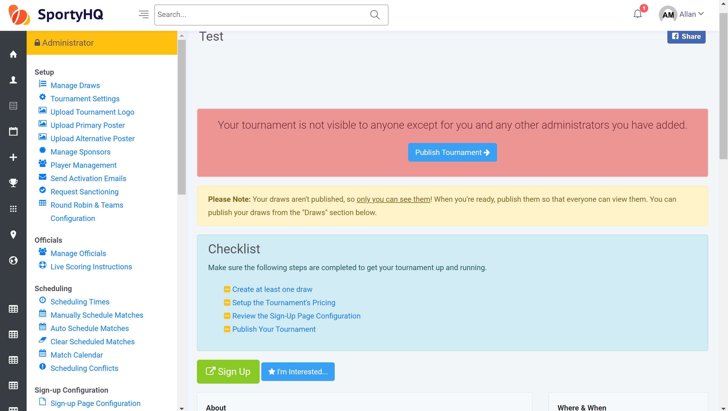
Scroll down on the tournament page and you will notice the box Checklist (see blue box above). This will help you fully set up your tournament and your tournament should not be published until these stages are all complete. You will notice as you complete a stage SportyHQ automatically puts a line through it to show it has been completed.

Firstly, click on Create at least one draw -> Create Draw
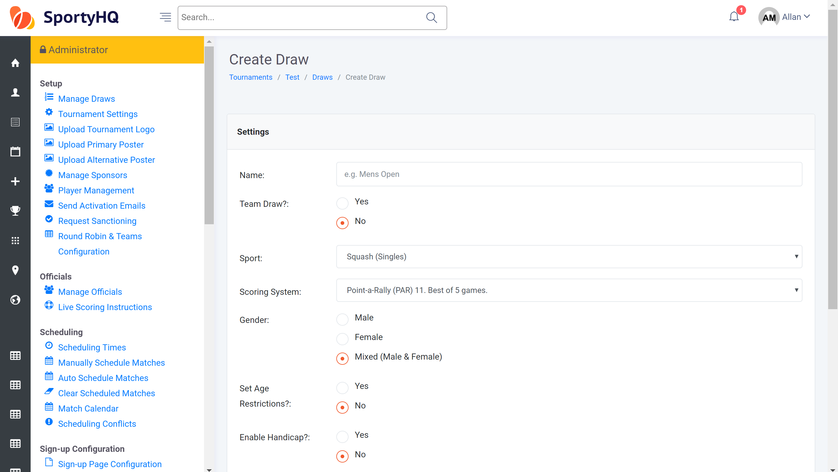
A new window will open to allow you to create your draws. Complete the stages of the page to set up a draw.
For competitions that have multiple draws, for example, junior tournaments (Boys and Girls under 11/13/15/17/19) and Masters tournaments you can use the box at the bottom to add them in quicker (see blue box below).
If you are unsure how your draws are going to be split in your competition, for example, for mixed graded events where draws may be split after the closing date depending on who enters, it is recommended that you create one draw called ‘All Entries’ as this will allow everyone to enter into one place.
Please note once you have created them you will need to go into each individual draw and change the settings for each one.
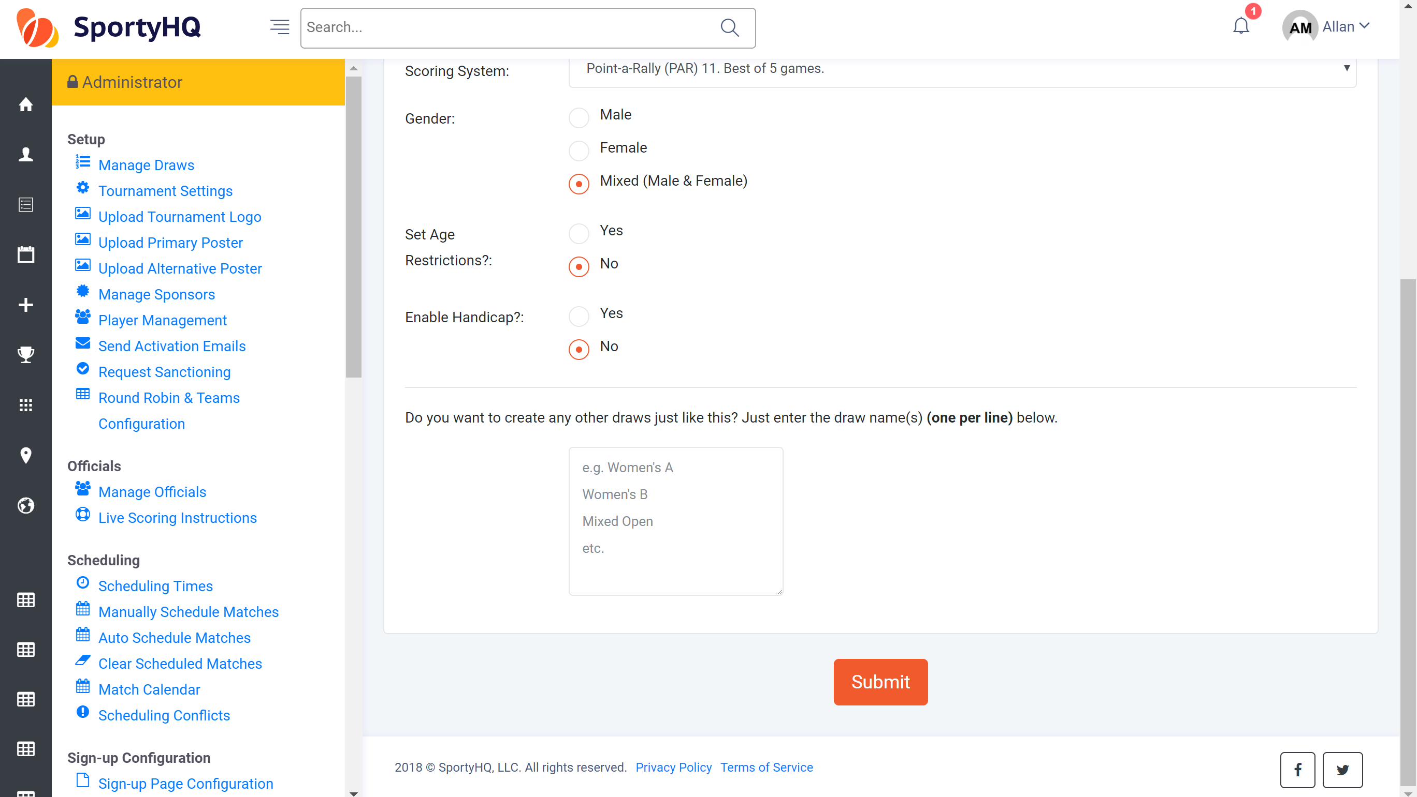
Once this page is completed click Submit.
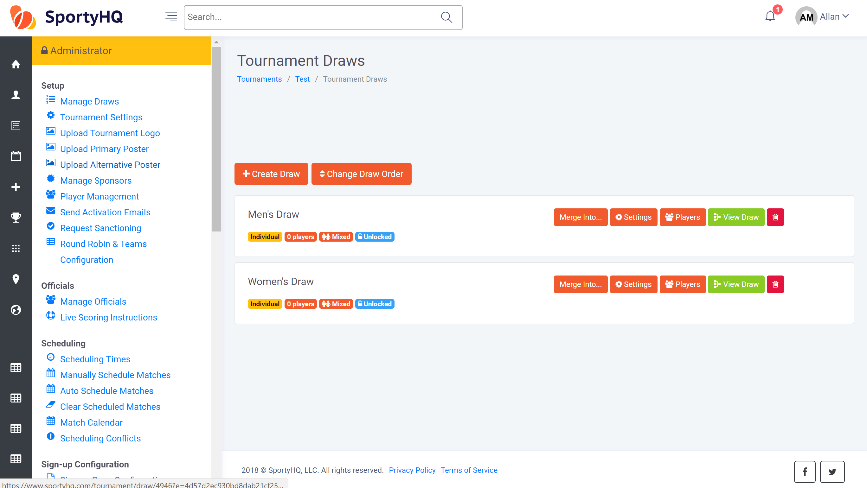
Your window will then look like the above with the different draws you created. If you used the box to create multiple draws remember you will need to go in and change the settings of each individual draw. (For example, you may need to change whether it is a male or female draw or the age of player the draw can accept).
To get back to the home page of the tournament click on The Name of the Competition at the top menu. See blue box below.
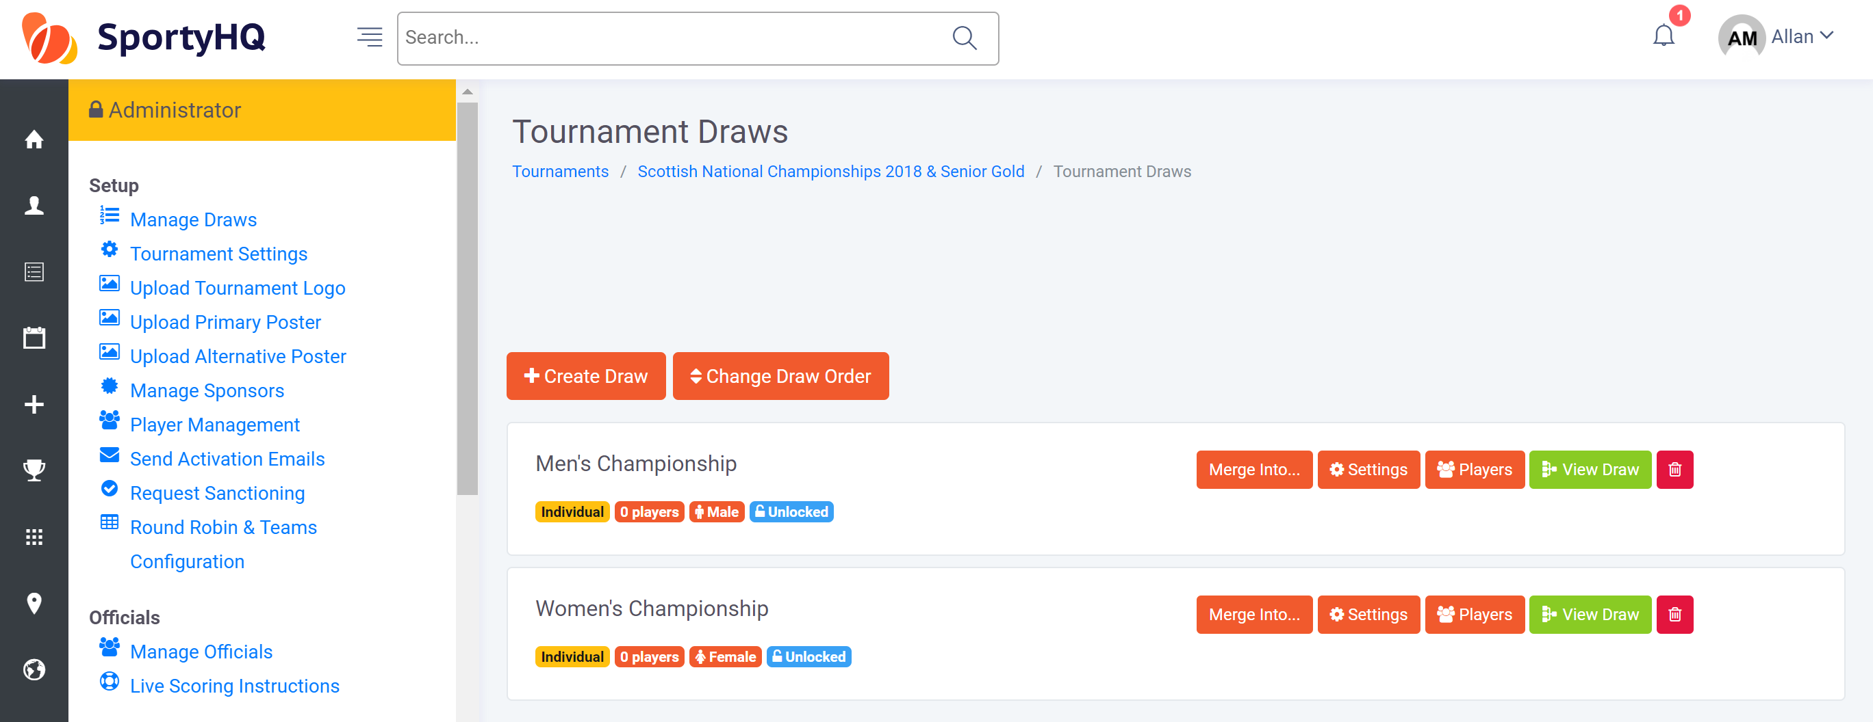
A line will then be placed through Create at least one draw in the checklist on the administrator page (see blue box below).
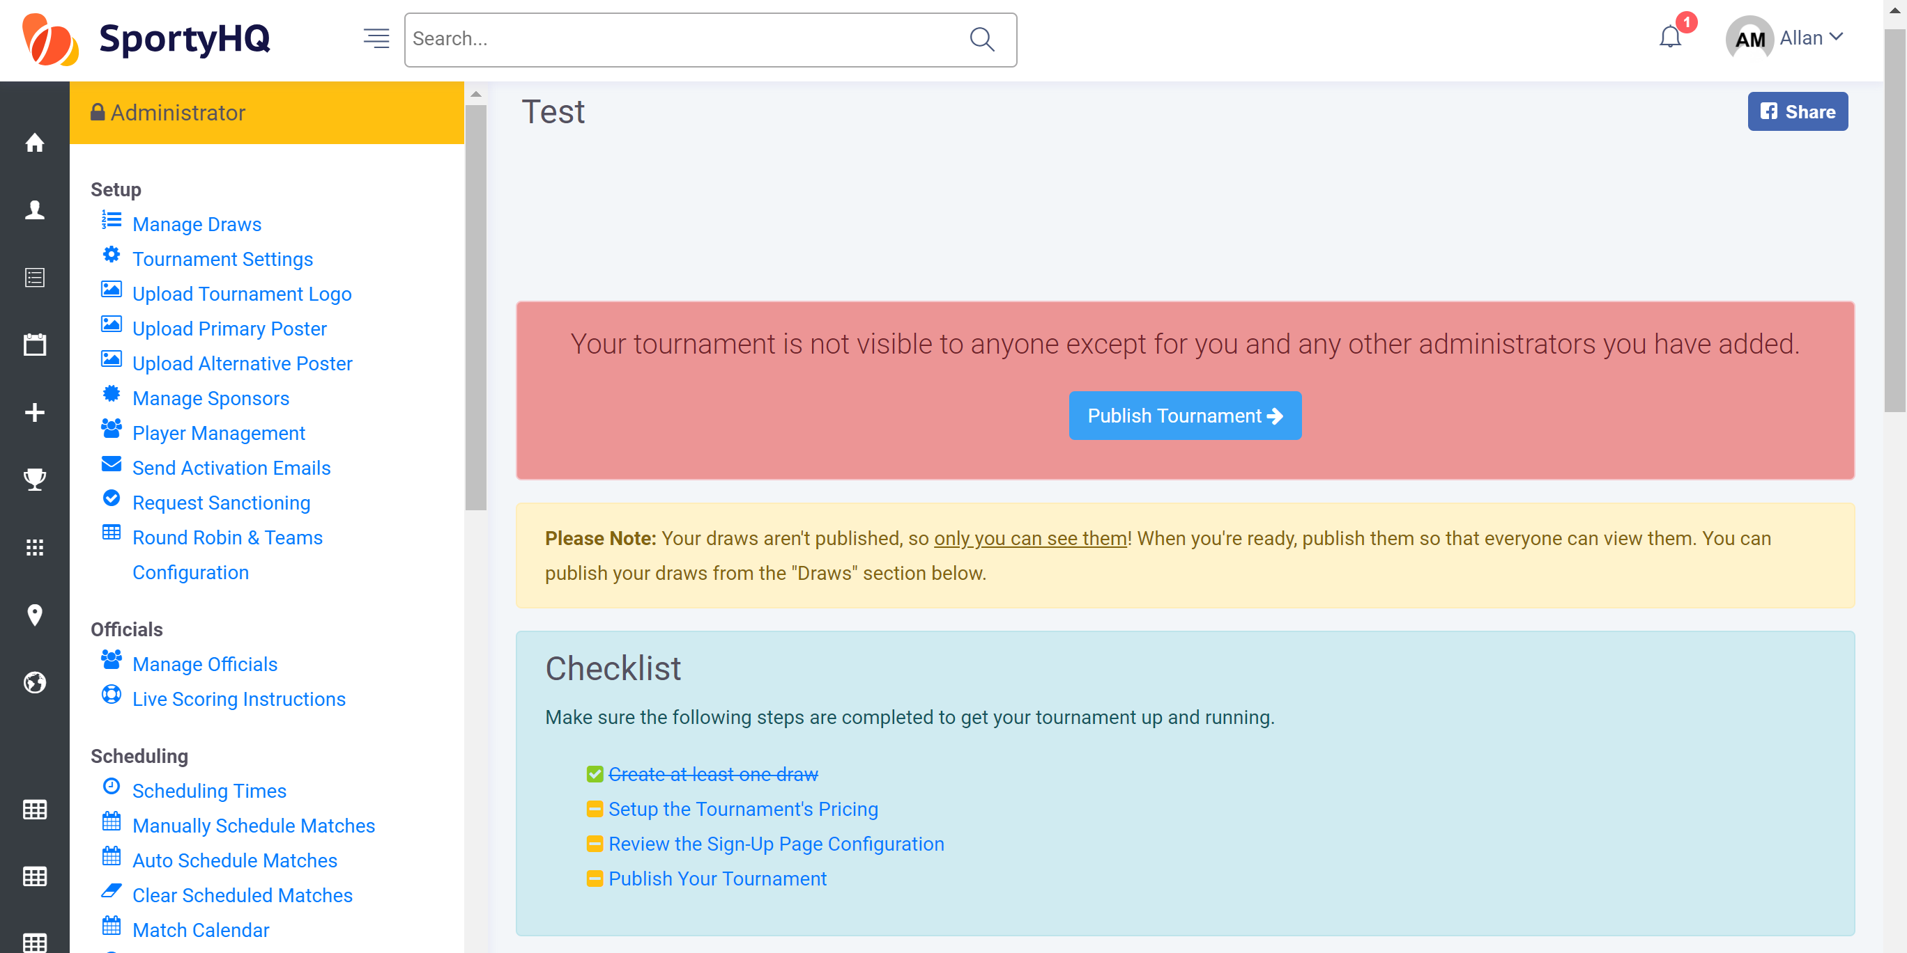
You then need to set up the payment for your tournament. In the checklist box click on Setup the Tournaments Pricing -> Create Payment Category.
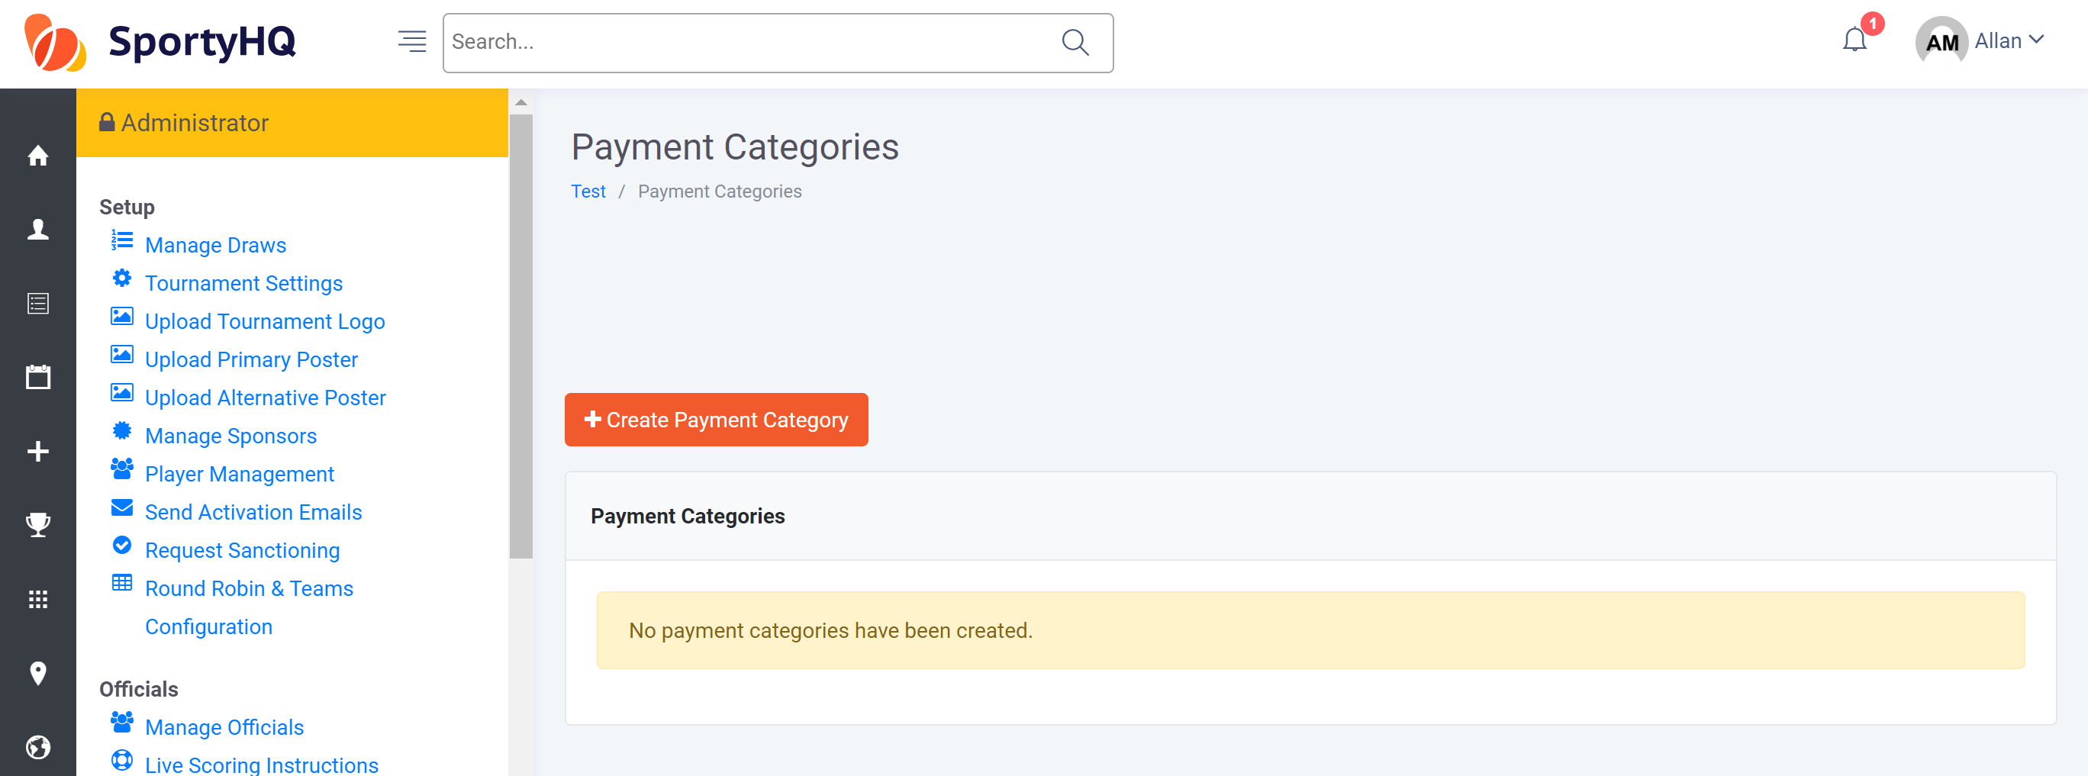
The above window will open and you should complete the information required. You can set up different prices for different people. For example, you may wish to set up more than one price category if you want your event to cost a different amount for juniors and adults. If the cost is the same for all we recommend you call the name of the price category ‘All Entries’.
There are also options for an ‘Early Bird’ sign up rate or different costs if you enter multiple events.
Guidelines on Scottish Squash’s entry fees are available in the Scottish Squash Sanctioned Event Guidelines document.
Once completed click Submit.
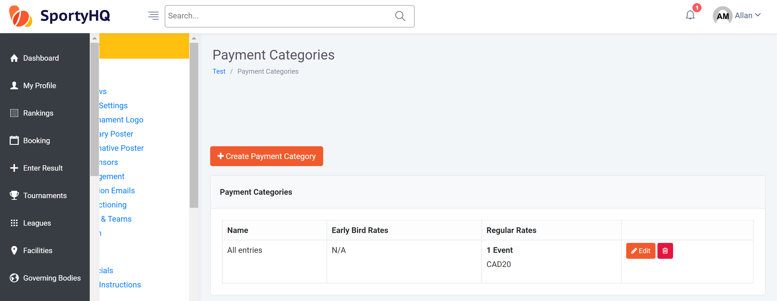
Your different payment categories are then shown in this window. Click on the Name of your tournament again in the top menu (see blue box above) to take you back to the home page.
You will then notice that Set the Tournament Pricing is also scored off the checklist.
To allow the entry fees to be paid out on completion of the tournament you need to input the payout settings. To do this click on Payout Settings under the Sign-up Configuration column (see blue box below).
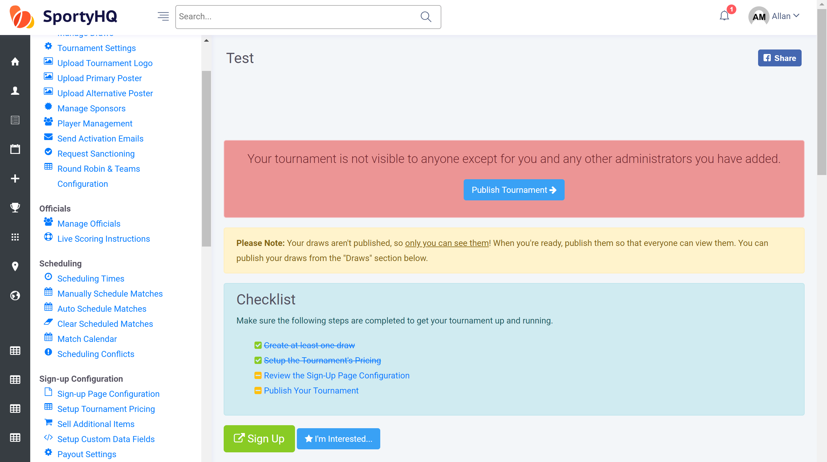
The following window will open.
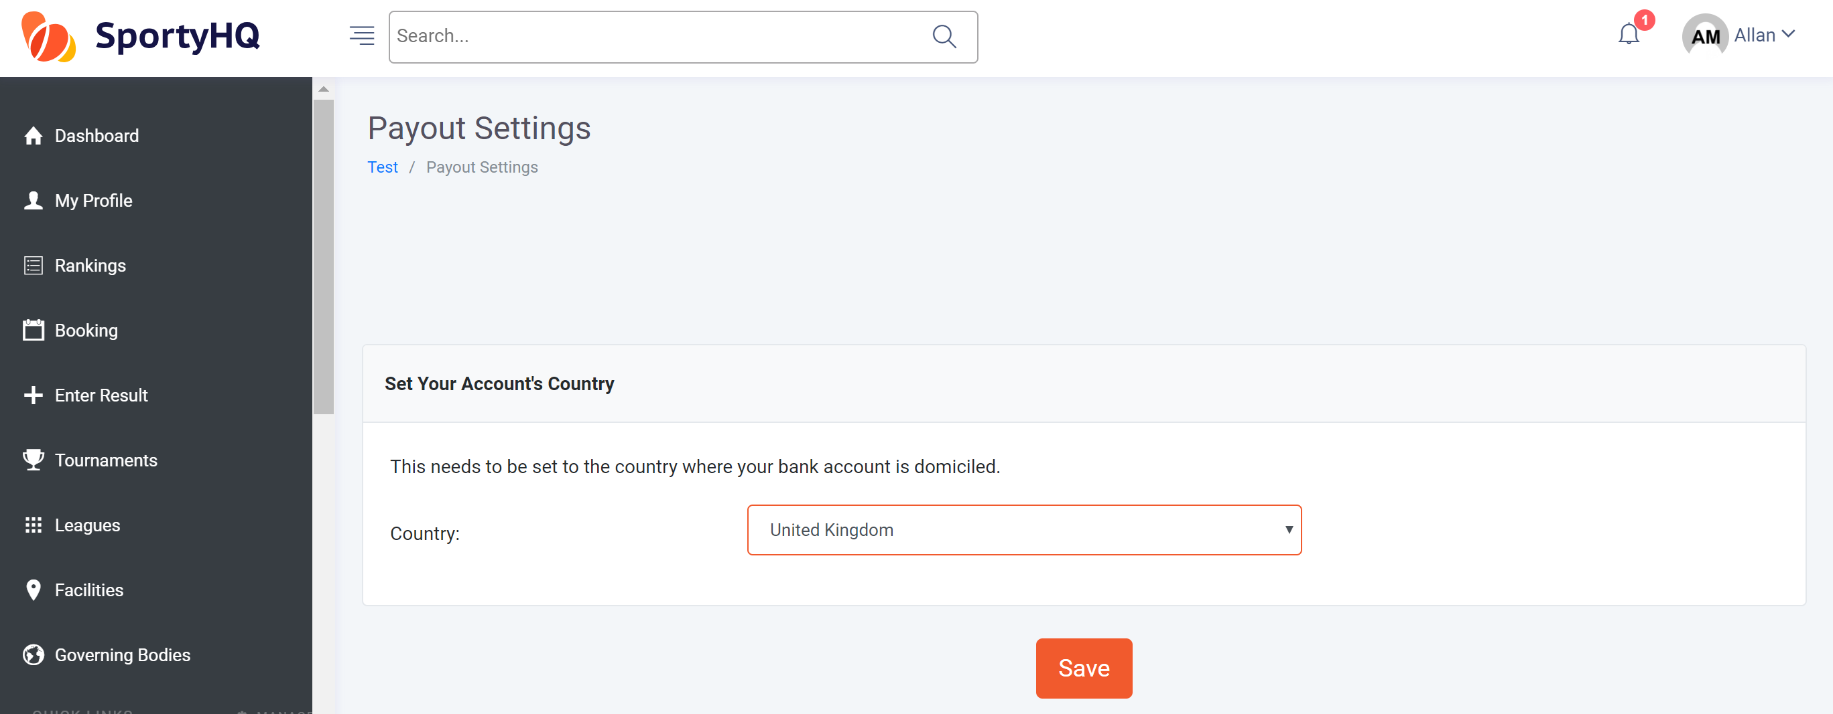
You need to either select ‘United Kingdon’ from the drop down menu. Click Save. You will then need to select the bank account if the details have been entered previously or input the details by following the on screen instructions. Once this has been done click on Save at the bottom of the page. You will then be taken back to the tournament administrator panel.

Click on Review the Sign-Up Page Configuration.
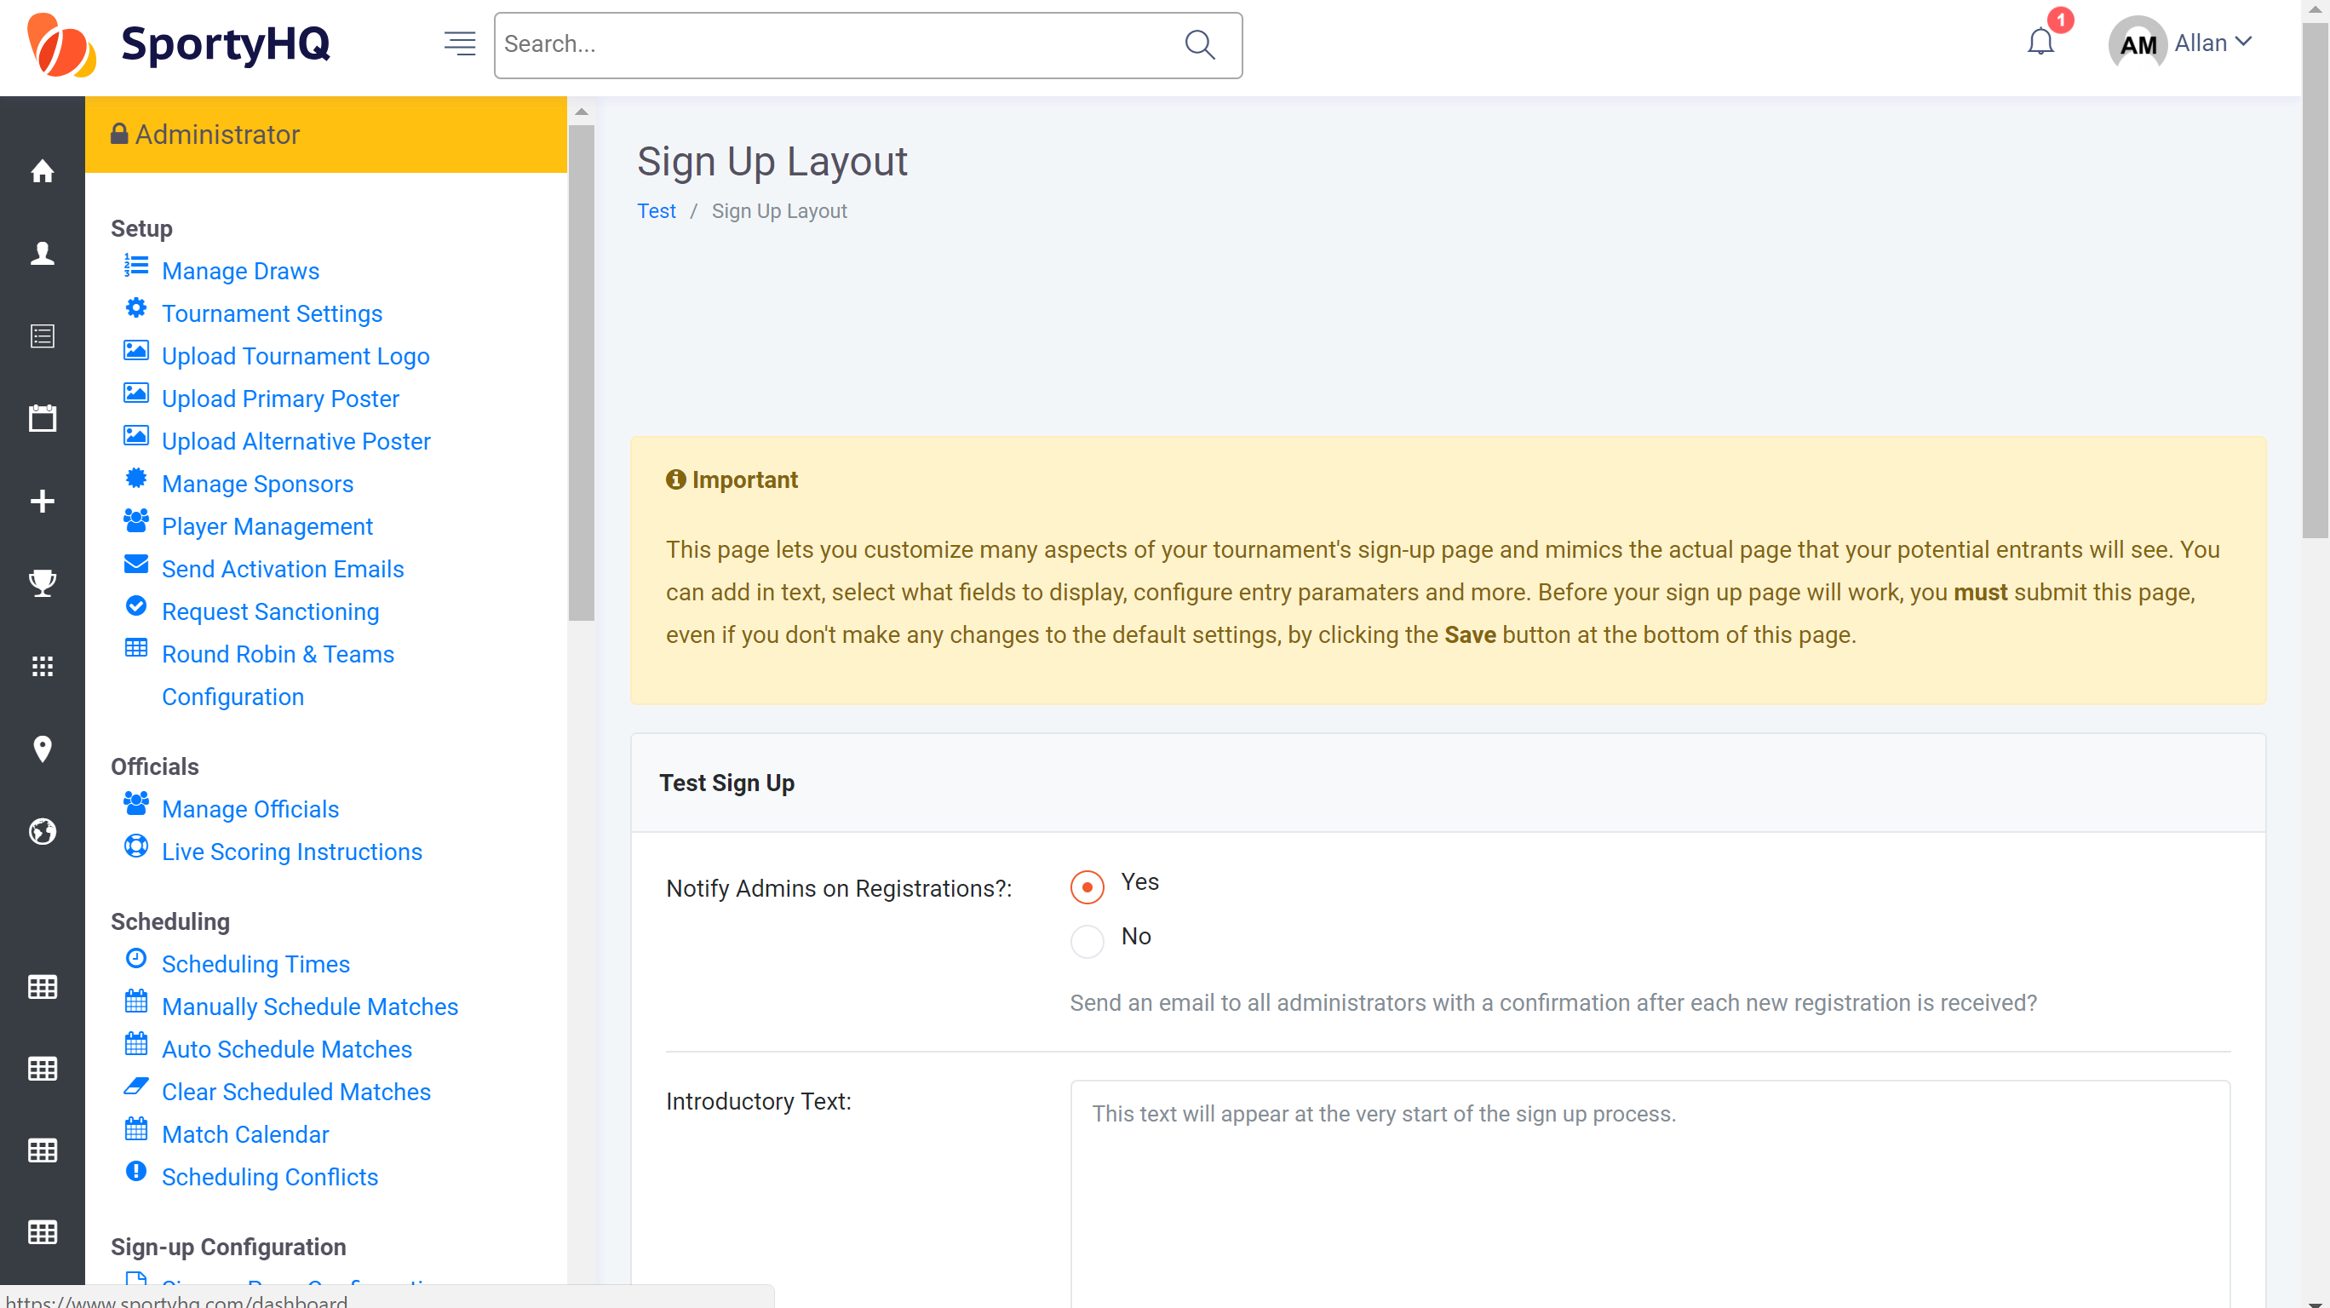
The above window will open. Here you can add in any other information you want players to see as they sign-up for your tournament. This is the section that you should also select the proper currency for your tournament. There are also other options here to restrict your entry to a certain number.
There is also an option to allow for players to show their availability, if you want to build your tournament around this. If you would rather set the match times of your tournament and give the players no option, then this should be set to ‘No’.
You can also add in any terms and conditions of the tournament in here. Players will have to tick the box to agree to these before completing their sign up. Standard terms and conditions can be obtained by Scottish Squash through our website by clicking here.
Click Save.

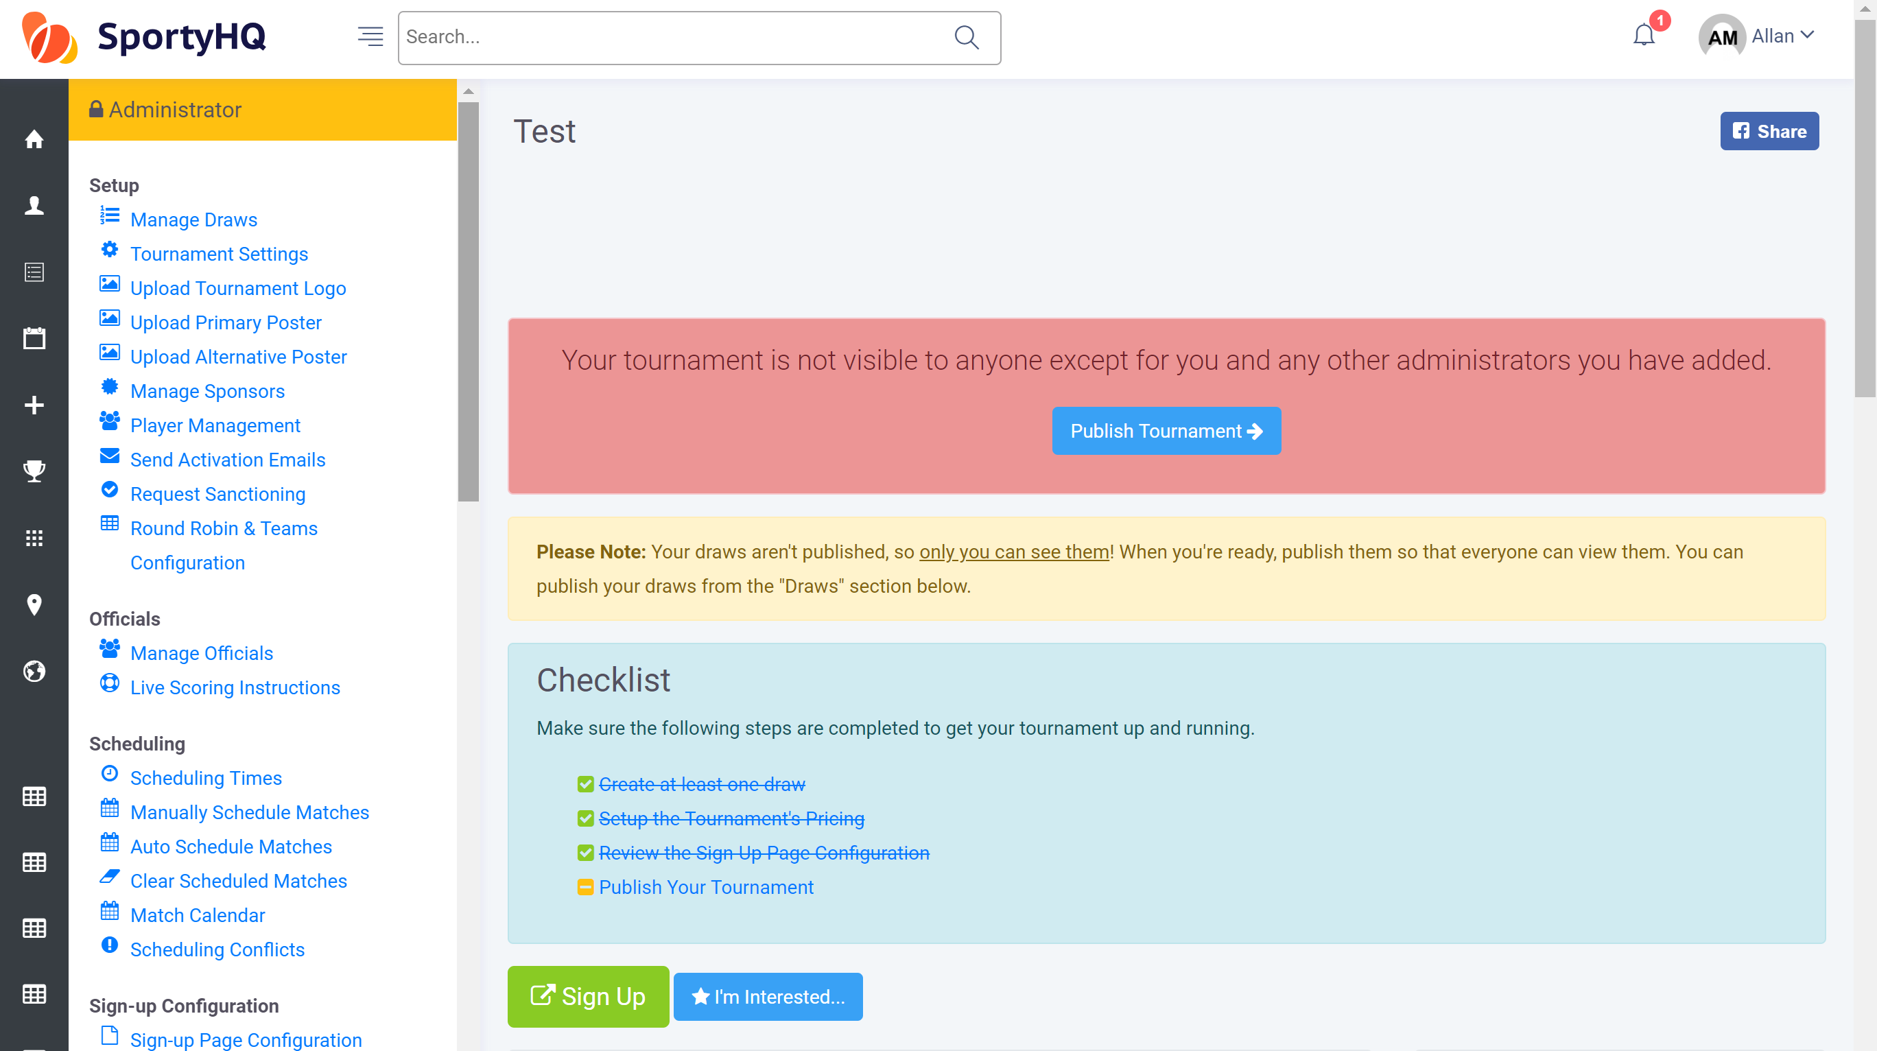
It will then take you back to the tournament administrator page and Review the Sign-Up Page Configuration will be scored off.
The last thing to do is Publish Your Tournament. To do this click on Publish Your Tournament. You will get a notification that SportyHQ are looking over your event and once it has been published you will receive an e-mail notification. Please note this may take a couple of hours. At this stage, your tournament will be live for everyone to see and enter.

- Sanctioning Your Tournament
If your tournament is a Scottish Squash sanctioned tournament it is important you request sanctioning. This can be done from the main tournament administrator page under the ‘Setup’ column on the left hand administrator panel (see blue box below).
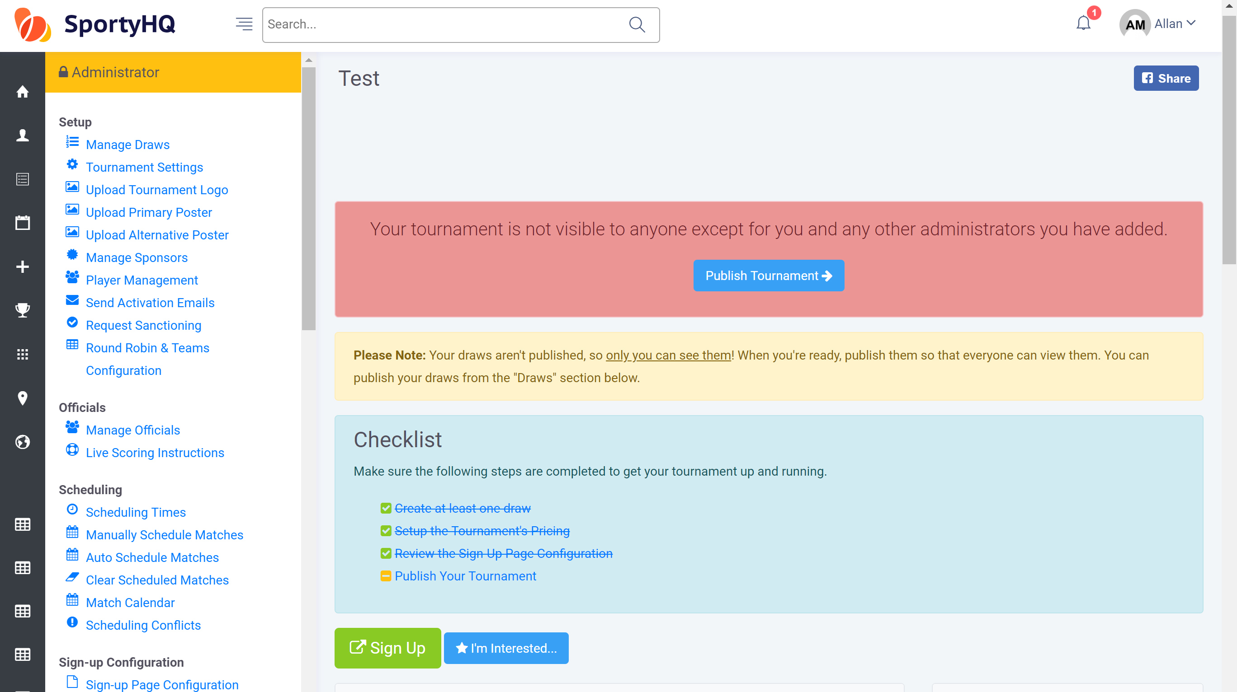
To request sanctioning click on Request Sanctioning.
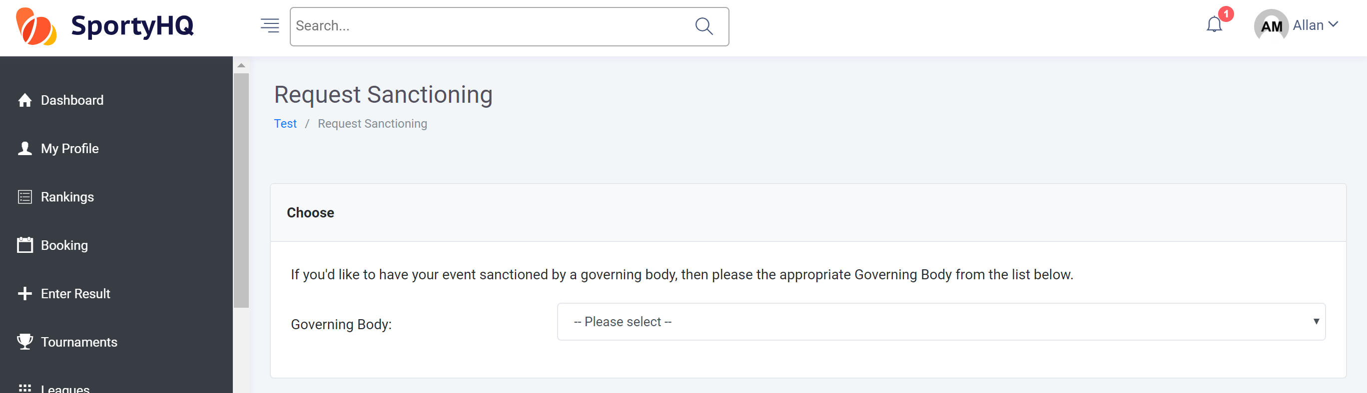
The above page will load. Click the dropdown box and select Scottish Squash. Tick the box depending at what level your tournament has been sanctioned. Click the tick box to accept the terms and conditions and click Submit Sanctioning Request. The sanction request will be sent to Scottish Squash for approval. Following approval, it will automatically change the ranking multiplier to the appropriate standard for that event.

- Adding the Extra Detail
You can add in various other aspects to your page to make it look more user friendly. The majority of these are done under the Setup column.
You can add the following:
- A club or region logo by clicking Tournament Logo.
- A tournament poster by clicking Tournament Poster.
- Add sponsors information by clicking Manage Sponsor. You can also add sponsors logos which will be printed out on all tournament material.
- By clicking on Player Management, you can manage all your entries through the process and make any changes you need to.
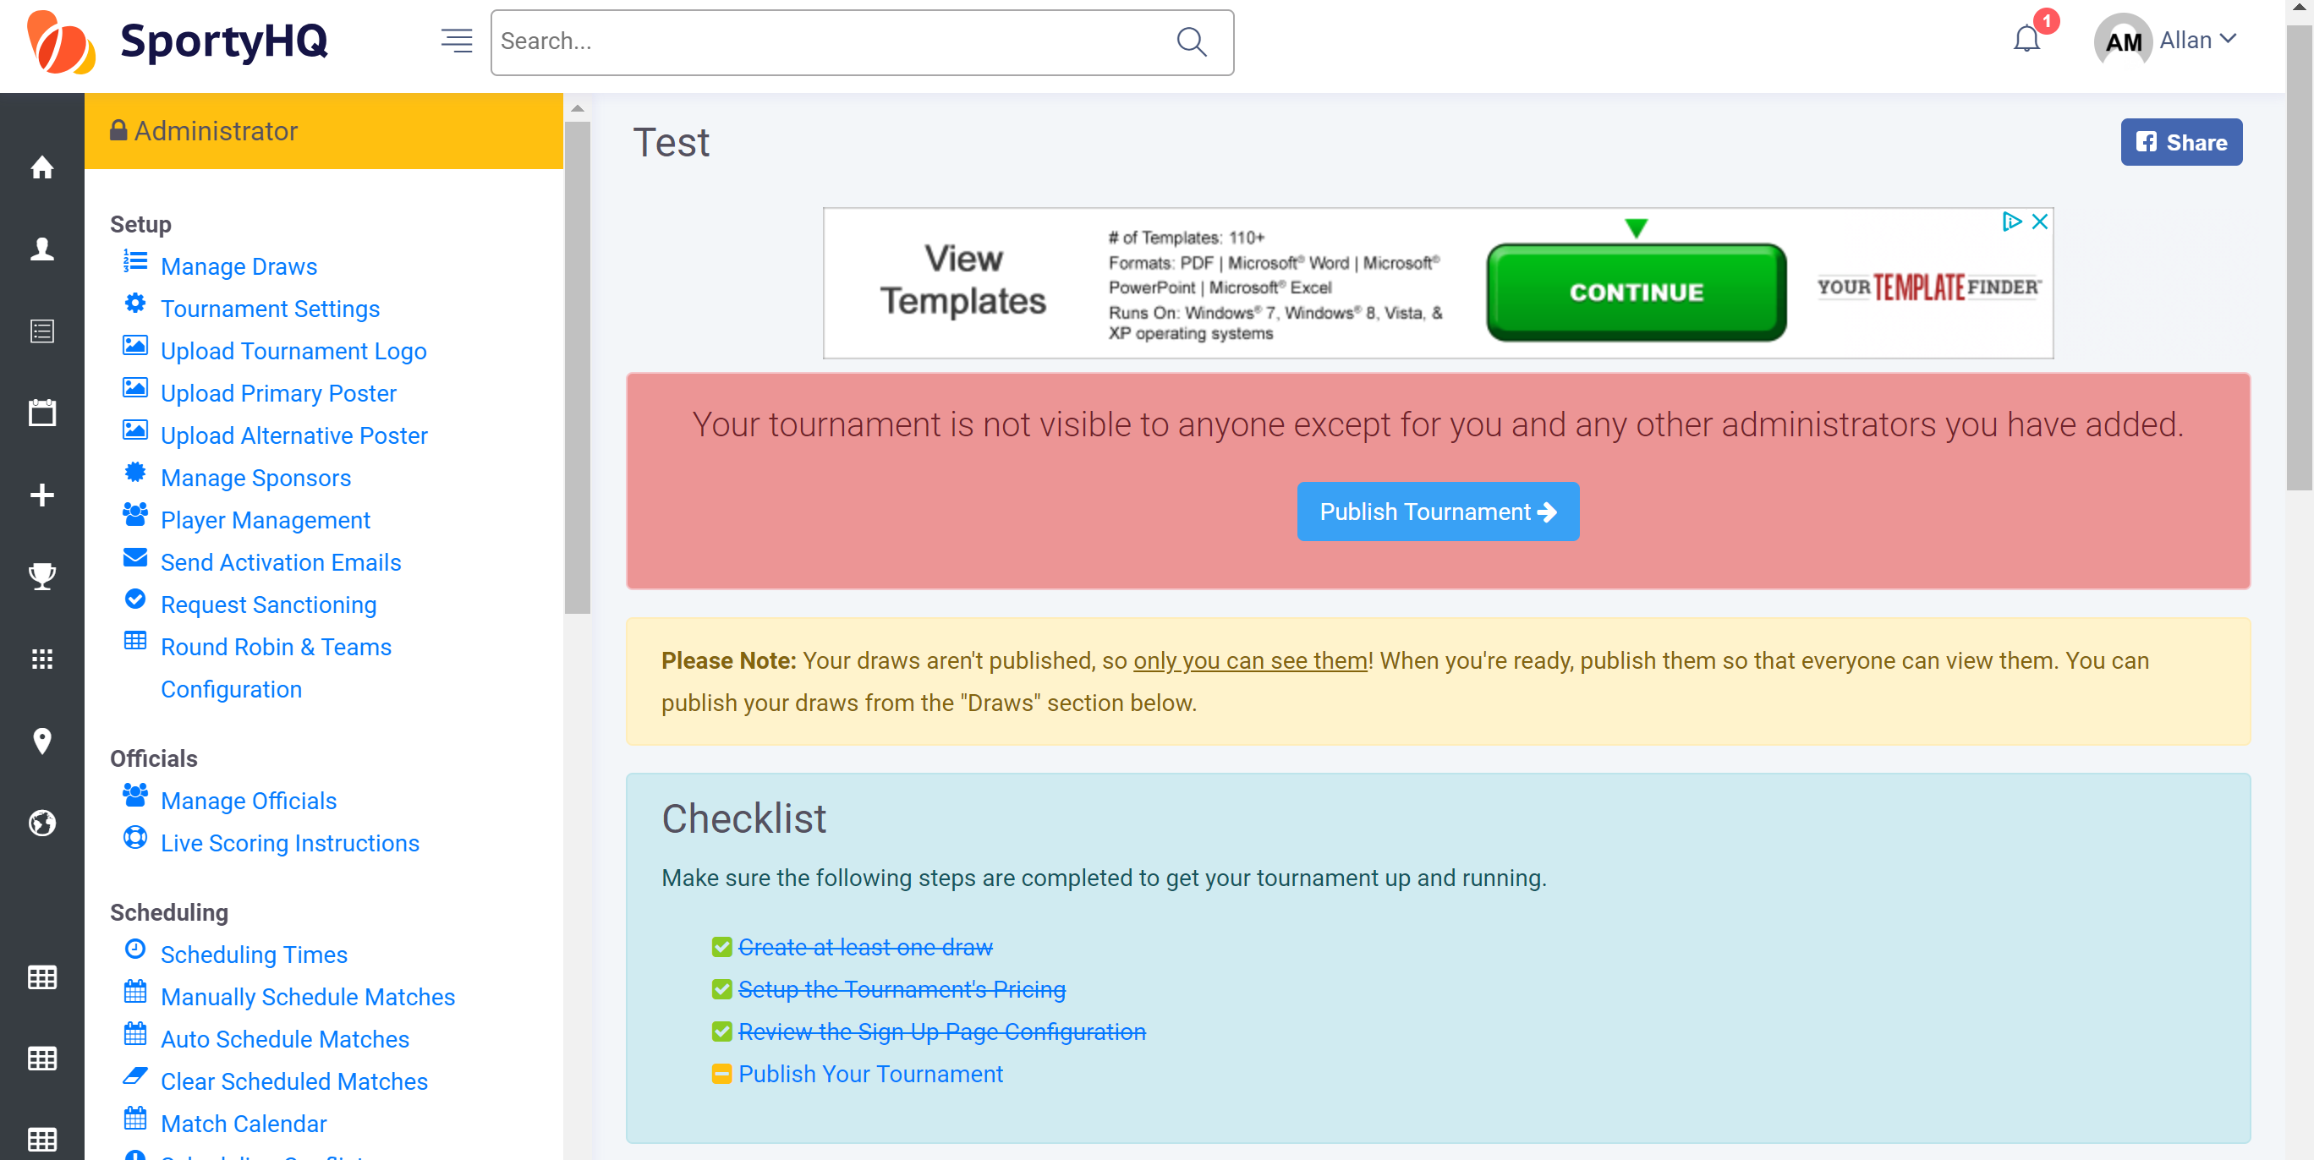

The Communicate and Share area is also a section that may be useful during the set-up of your tournament.
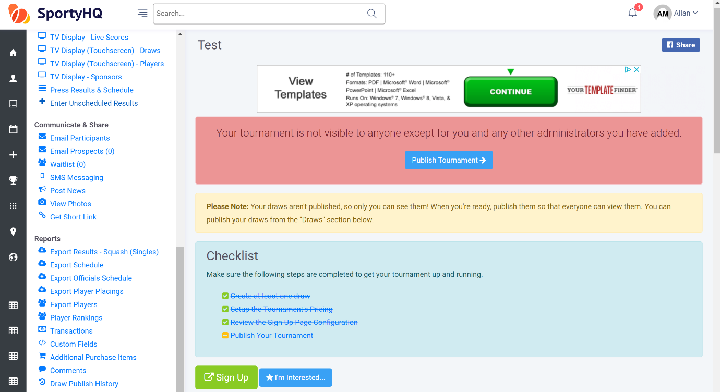
Email Participants allows you to communicate with the people that have registered for your tournament.
Get Short Link provides you with a short link straight to your tournament page. This can be useful for sharing through e-mail and social media channels.
Please note that players may leave comments along with their entry into the tournament. Tournament admins will not receive e-mail notifications for comments that have been left. It is recommended that tournament organisers regularly check the comments section. This can be done by clicking on Comments under the Reports column on the administrator panel (see red box above).

- Creating Draws
Following the closing date or after collecting all your entries for your competition you will be required to put together draws for the competition. SportyHQ offers a number of different draw formats to select from.
To begin to create your draws click on Manage Draws on the administrator panel of the tournament page on SportyHQ. You may already have various draws there depending how you set-up your sign-up page or you may only have one draw tab where all entries went to.
If you need to add in further draw categories click on Create Draw. Fill in the details on the new page and click Submit. These draws will now appear with the rest.

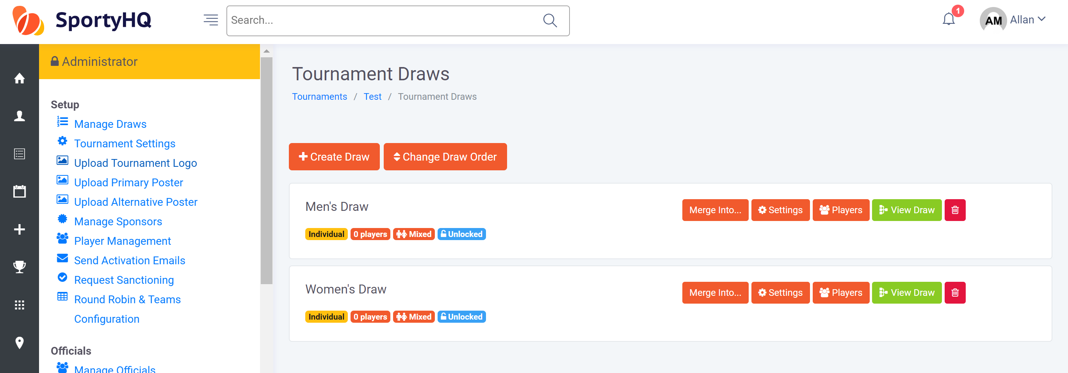
Once you are ready to create the draw for a specific category click on the green View Draw button. This will open a new window and is where you get to select different draw formats and sizes. Click on the dropdown box titles Please select a draw format. This will list all the different draw formats that are compatible on SportyHQ. Please check the further information below on draw formats.
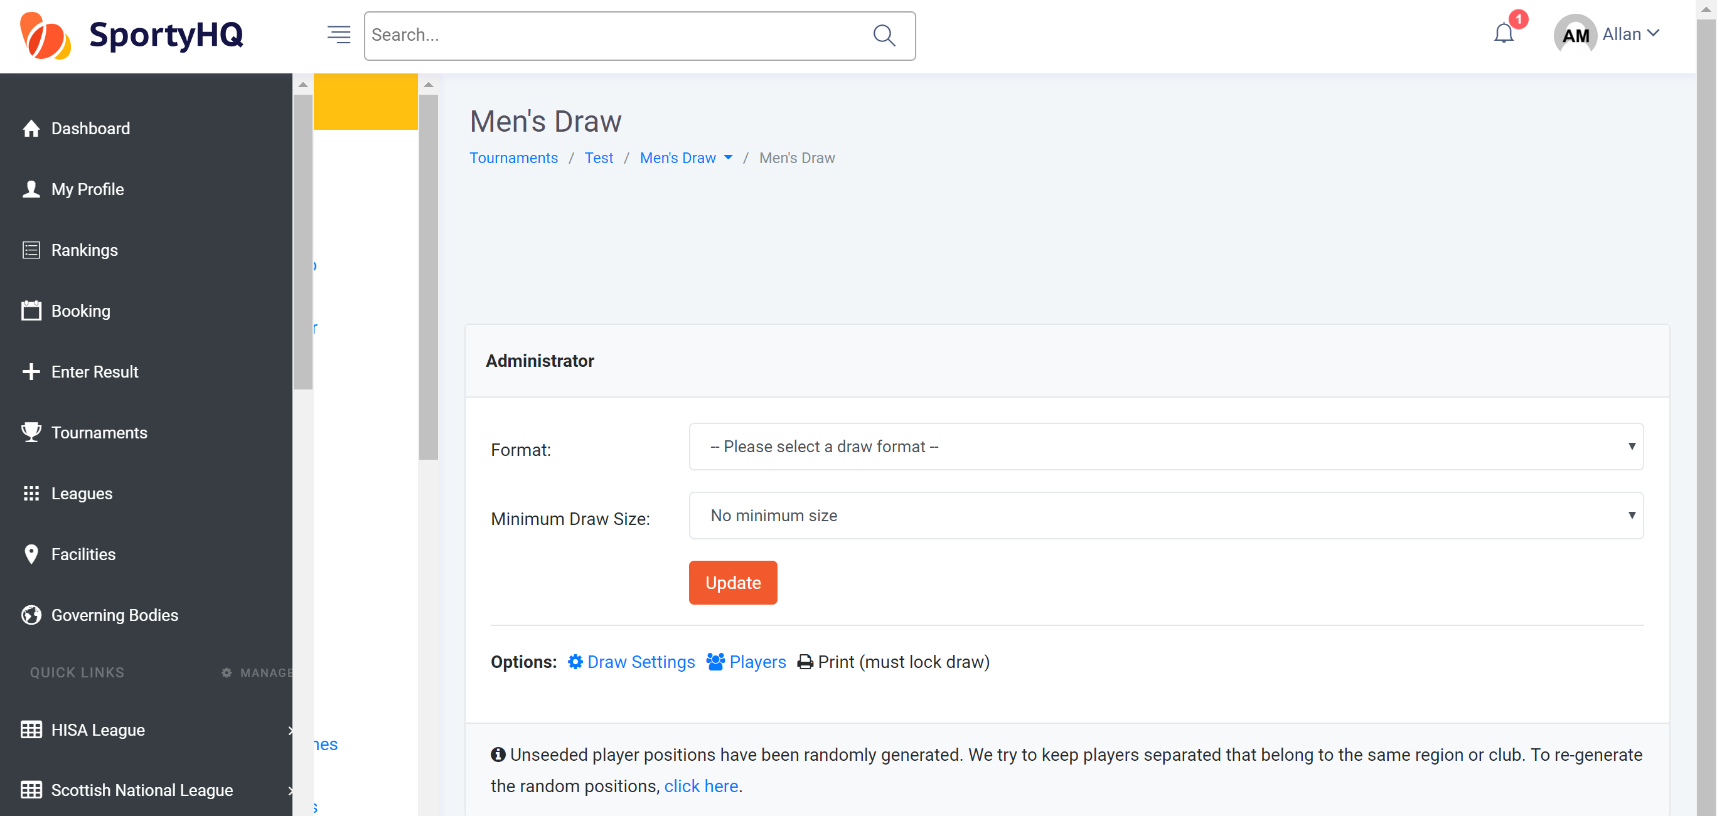
- ‘Bracket – 2 Match Guarantee – Standard’ – This is a standard knockout draw with a plate competition. These are normally used in Scottish Squash Masters Competitions.
- ‘Bracket – MONRAD Format’ – This is a draw where every player plays through to a final finishing position. These draws will be common in Senior and Junior Gold sanctioned competitions as well as Silver and Bronze competitions if individual Tournament Organisers decide they are best fitted to their event.
- ‘Swiss Draw’ – This draw players play in boxes and play through to a final finishing position. These draws are similar to the qualifying monrad draws used for all events at senior and junior level in previous seasons, however, they do not have the capability of providing the qualifying round at the beginning.
For Scottish Squash Masters Circuit competitions it is recommended to use the following draw structures if the time is available:
- 5 players or less: 1 round robin
- 6 players – 2 x round robin – semi-finals – final
- 7 players or more: knock-out
Once you are happy with your draw format it is important that you set the seeds in your draw. To do this click on the Players tab as shown in the picture below.
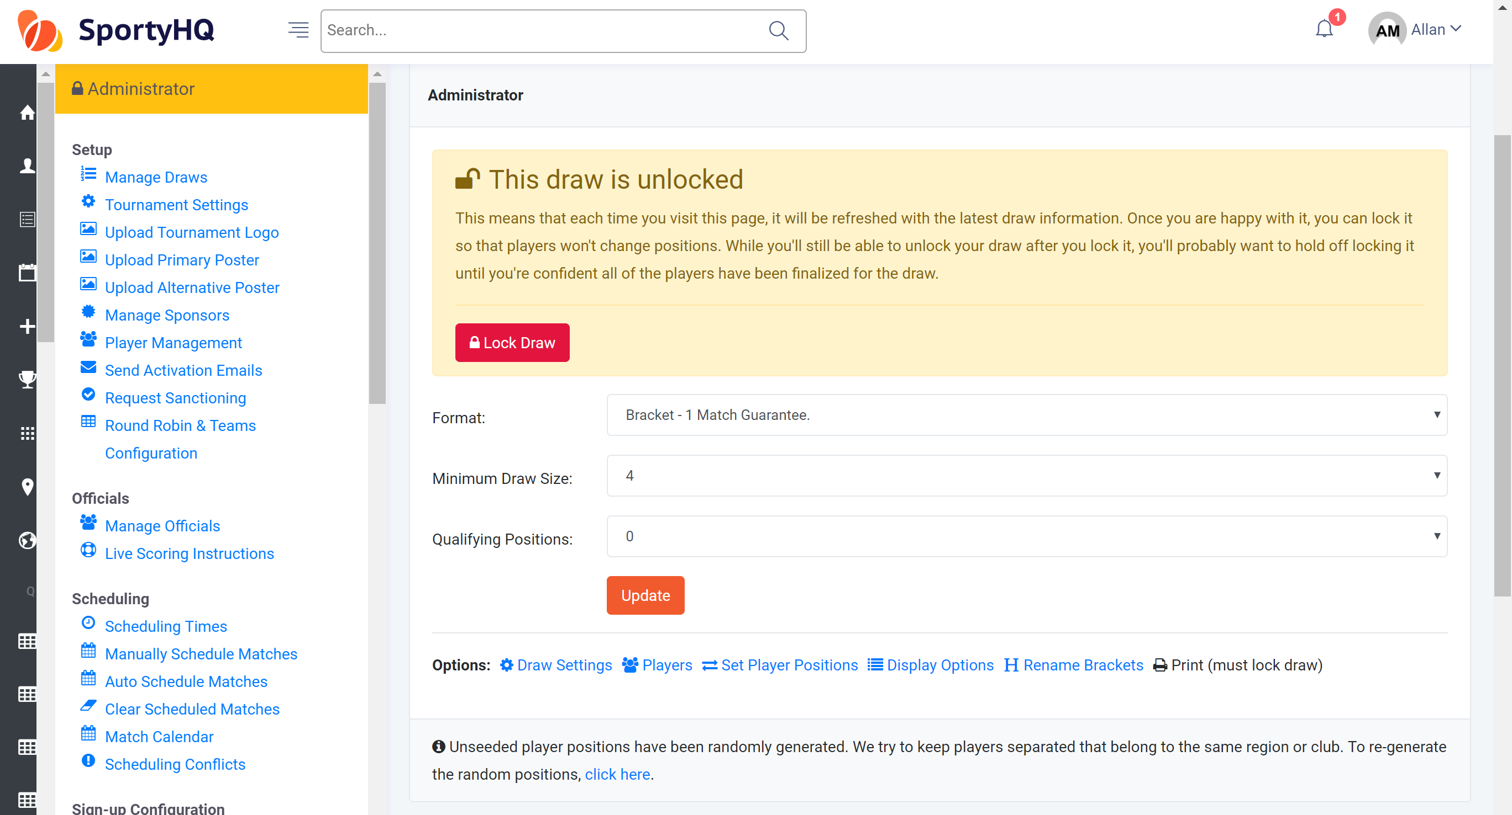

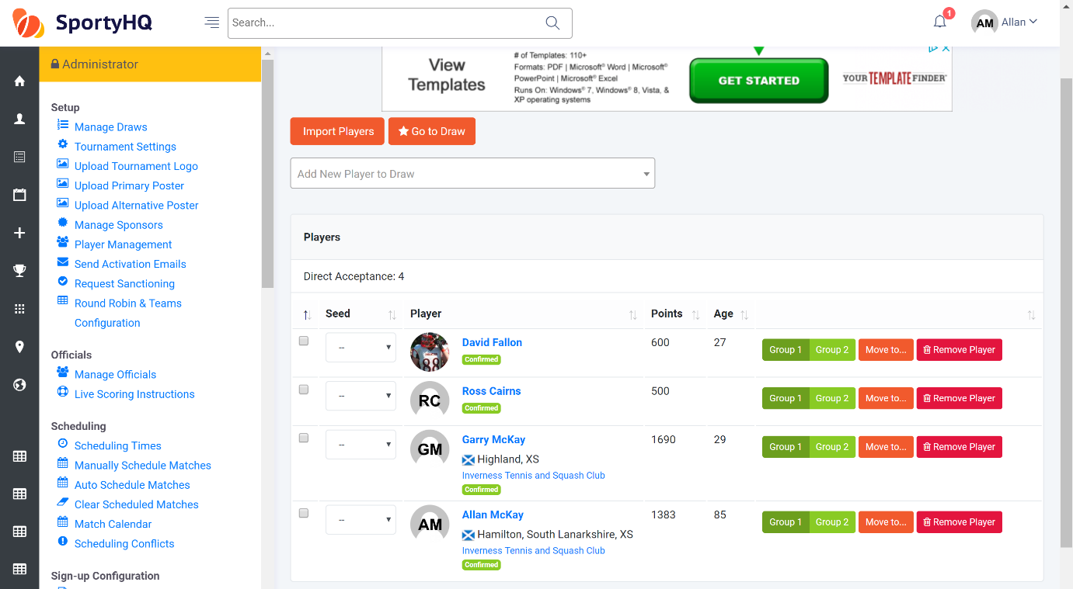
The following page should open.
On this page, you can select the seed number for each player by clicking on the drop down box next to their name. You can also do a number of other actions to tidy up the event before making the draw:
- You can also add in any further players by typing their name in to the box titled Add New Player to Draw.
- You can remove players by clicking the red Remove Player button
- You can move players to other categories by clicking the blue Move to… button. This will then open a new window with a drop-down menu of where to move the player to.
Once you have selected your seeded players and you click on Go To Draw.
The page will then open showing your draw you have generated.
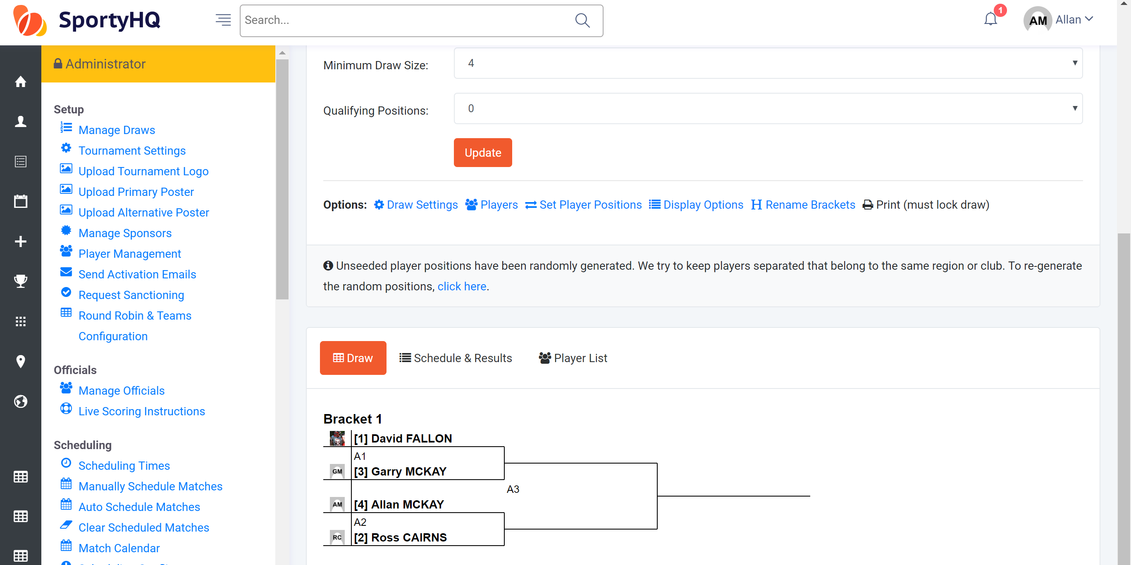
At this stage, you are still able to make changes. A change that may need to be made at this stage is the position of the seeds within the draw.
Scottish Squash sanctioned events normally run competitions with seeds playing each other at the following stages:
Last 16 – 1v16 | 2v15 | 3v14 | 4v13 | 5v12 | 6v11 | 7v10 | 8v9 |
Quarter-finals – 1v8 | 2v7 | 3v6 | 4v5 |
Semi-finals – 1v4 | 2v4 |
This can be changed by clicking on Set Player Positions. The following window will open.
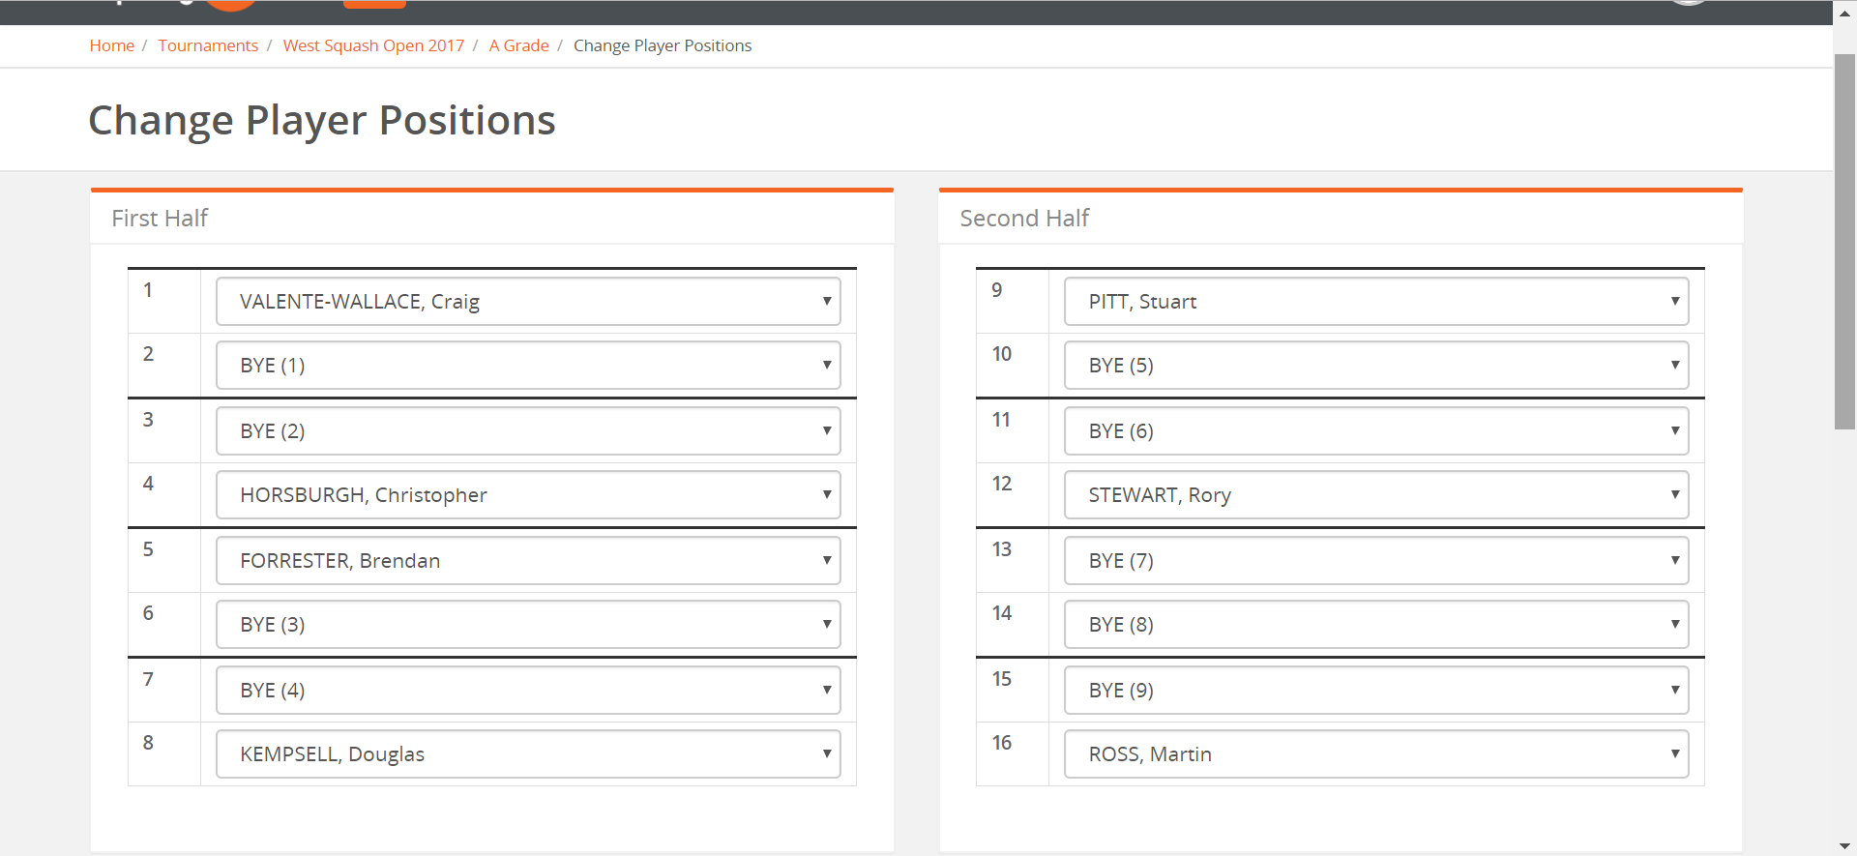
On this page, you can move the seeds around accordingly. Once they are placed in the correct position click Save and it will take you back to the draws with the changes you made.
After this your draw is most likely complete. Before moving on to any other draws or scheduling the draws it is important you lock the draw. To lock the draw, you click on the red button called Lock Draw.
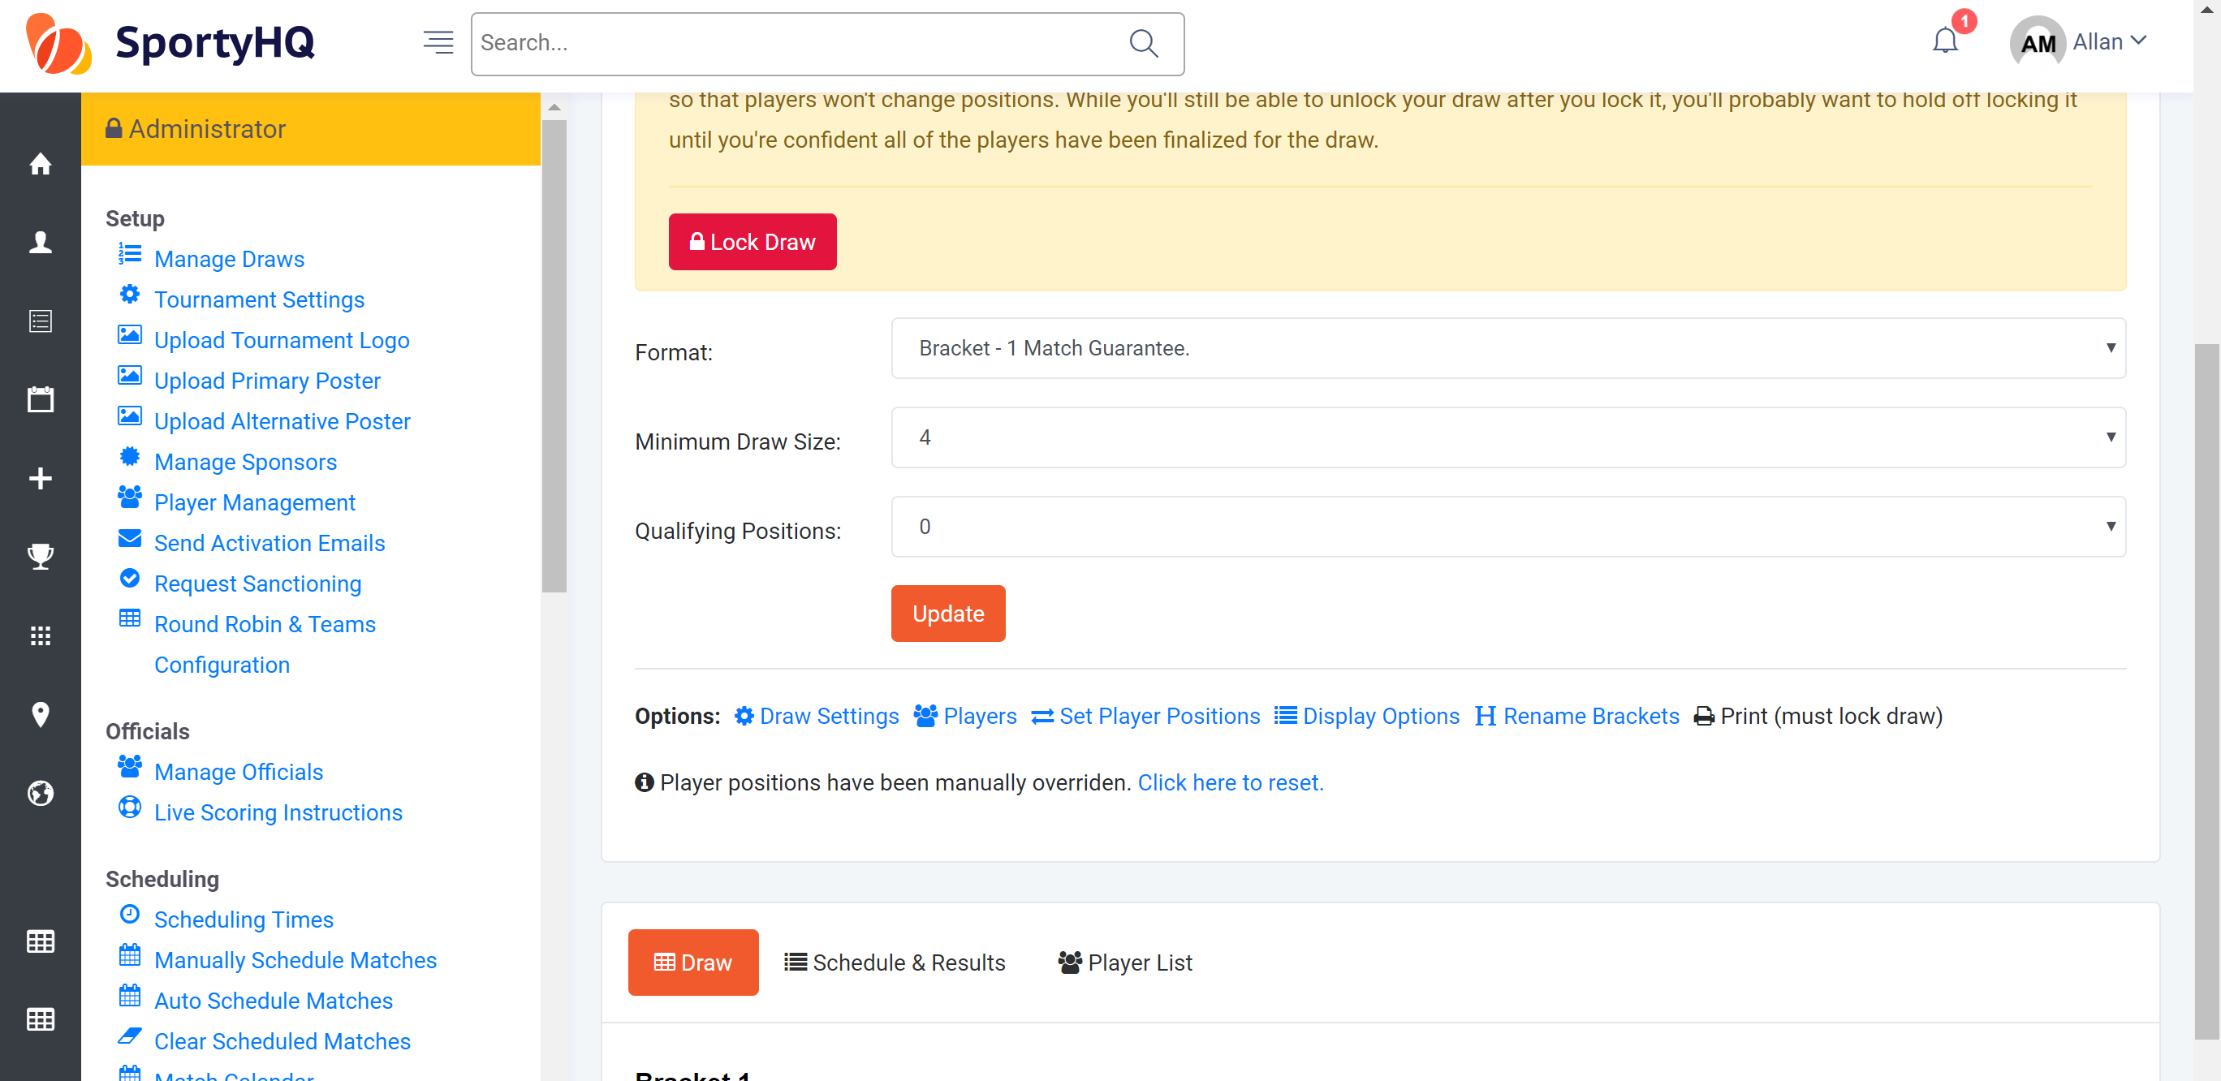
This draw is now complete and ready to be scheduled. If you have further draws to make the above process should be followed for each one and each draw should be locked individually before moving on to the schedule. Please note you will not be able to schedule if you have not locked your draws.

- Creating the Schedule
Once you have created your draws and they are locked it is time to build the schedule for the event. This is all done with the tools under the scheduling column on the administrator page or your tournament.
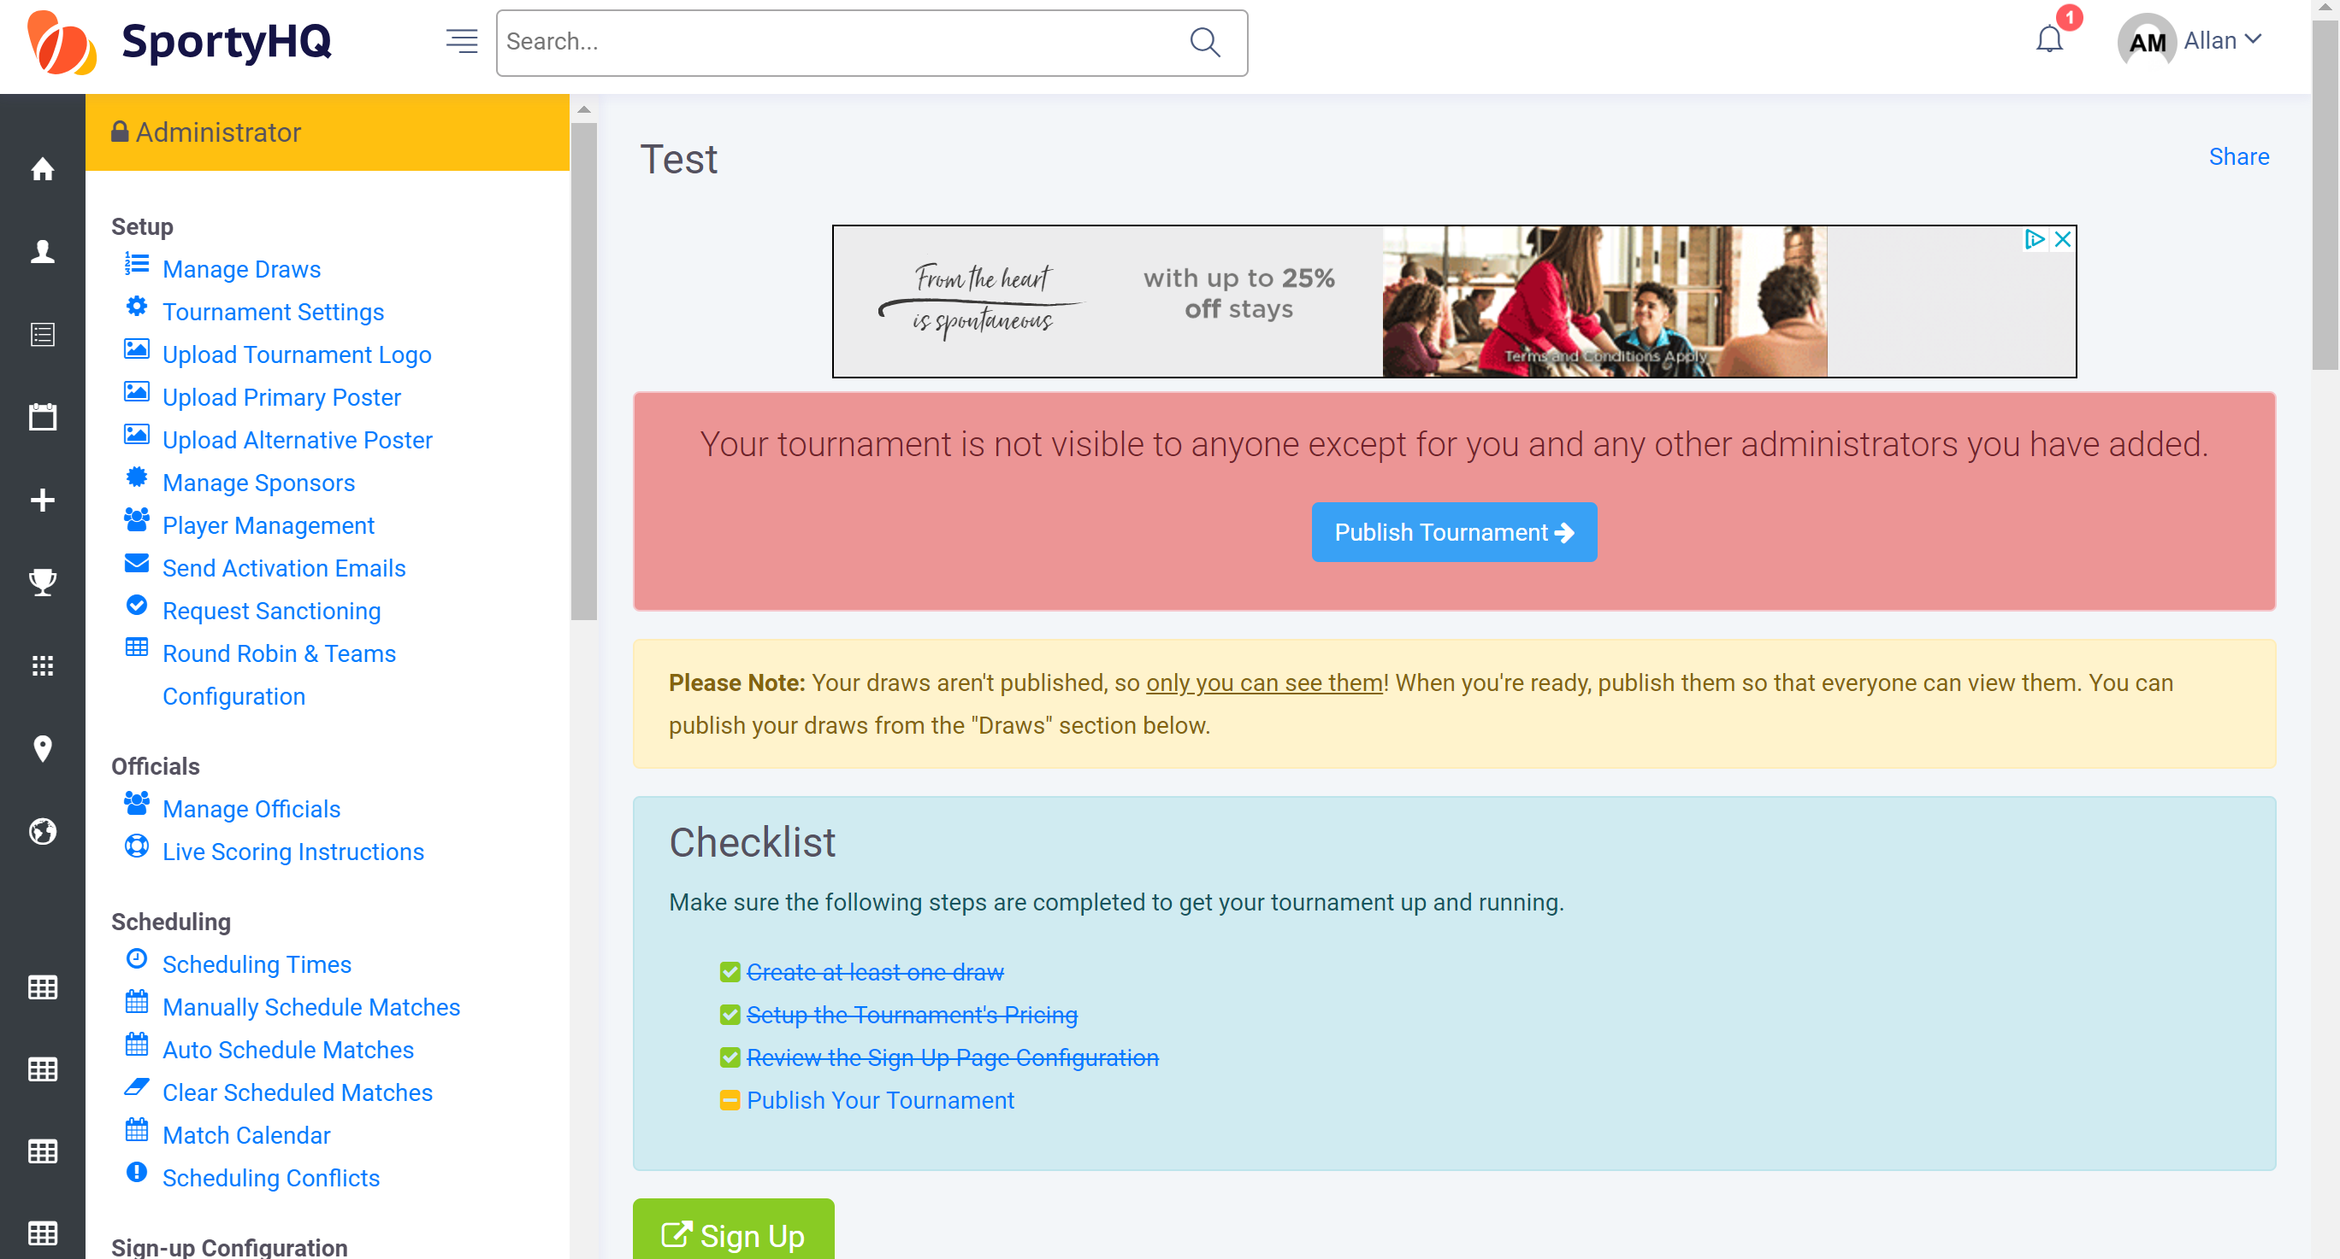
Firstly, you need to input the scheduling times of the event. This is the times that you want the competition to start and finish. Please note if you put the start and finish time far apart for a competition that has a light schedule it will spread the matches out to use the whole time available. This may need changed now and then to make your schedule work. To set the times click on Scheduling Times, the following window will open.
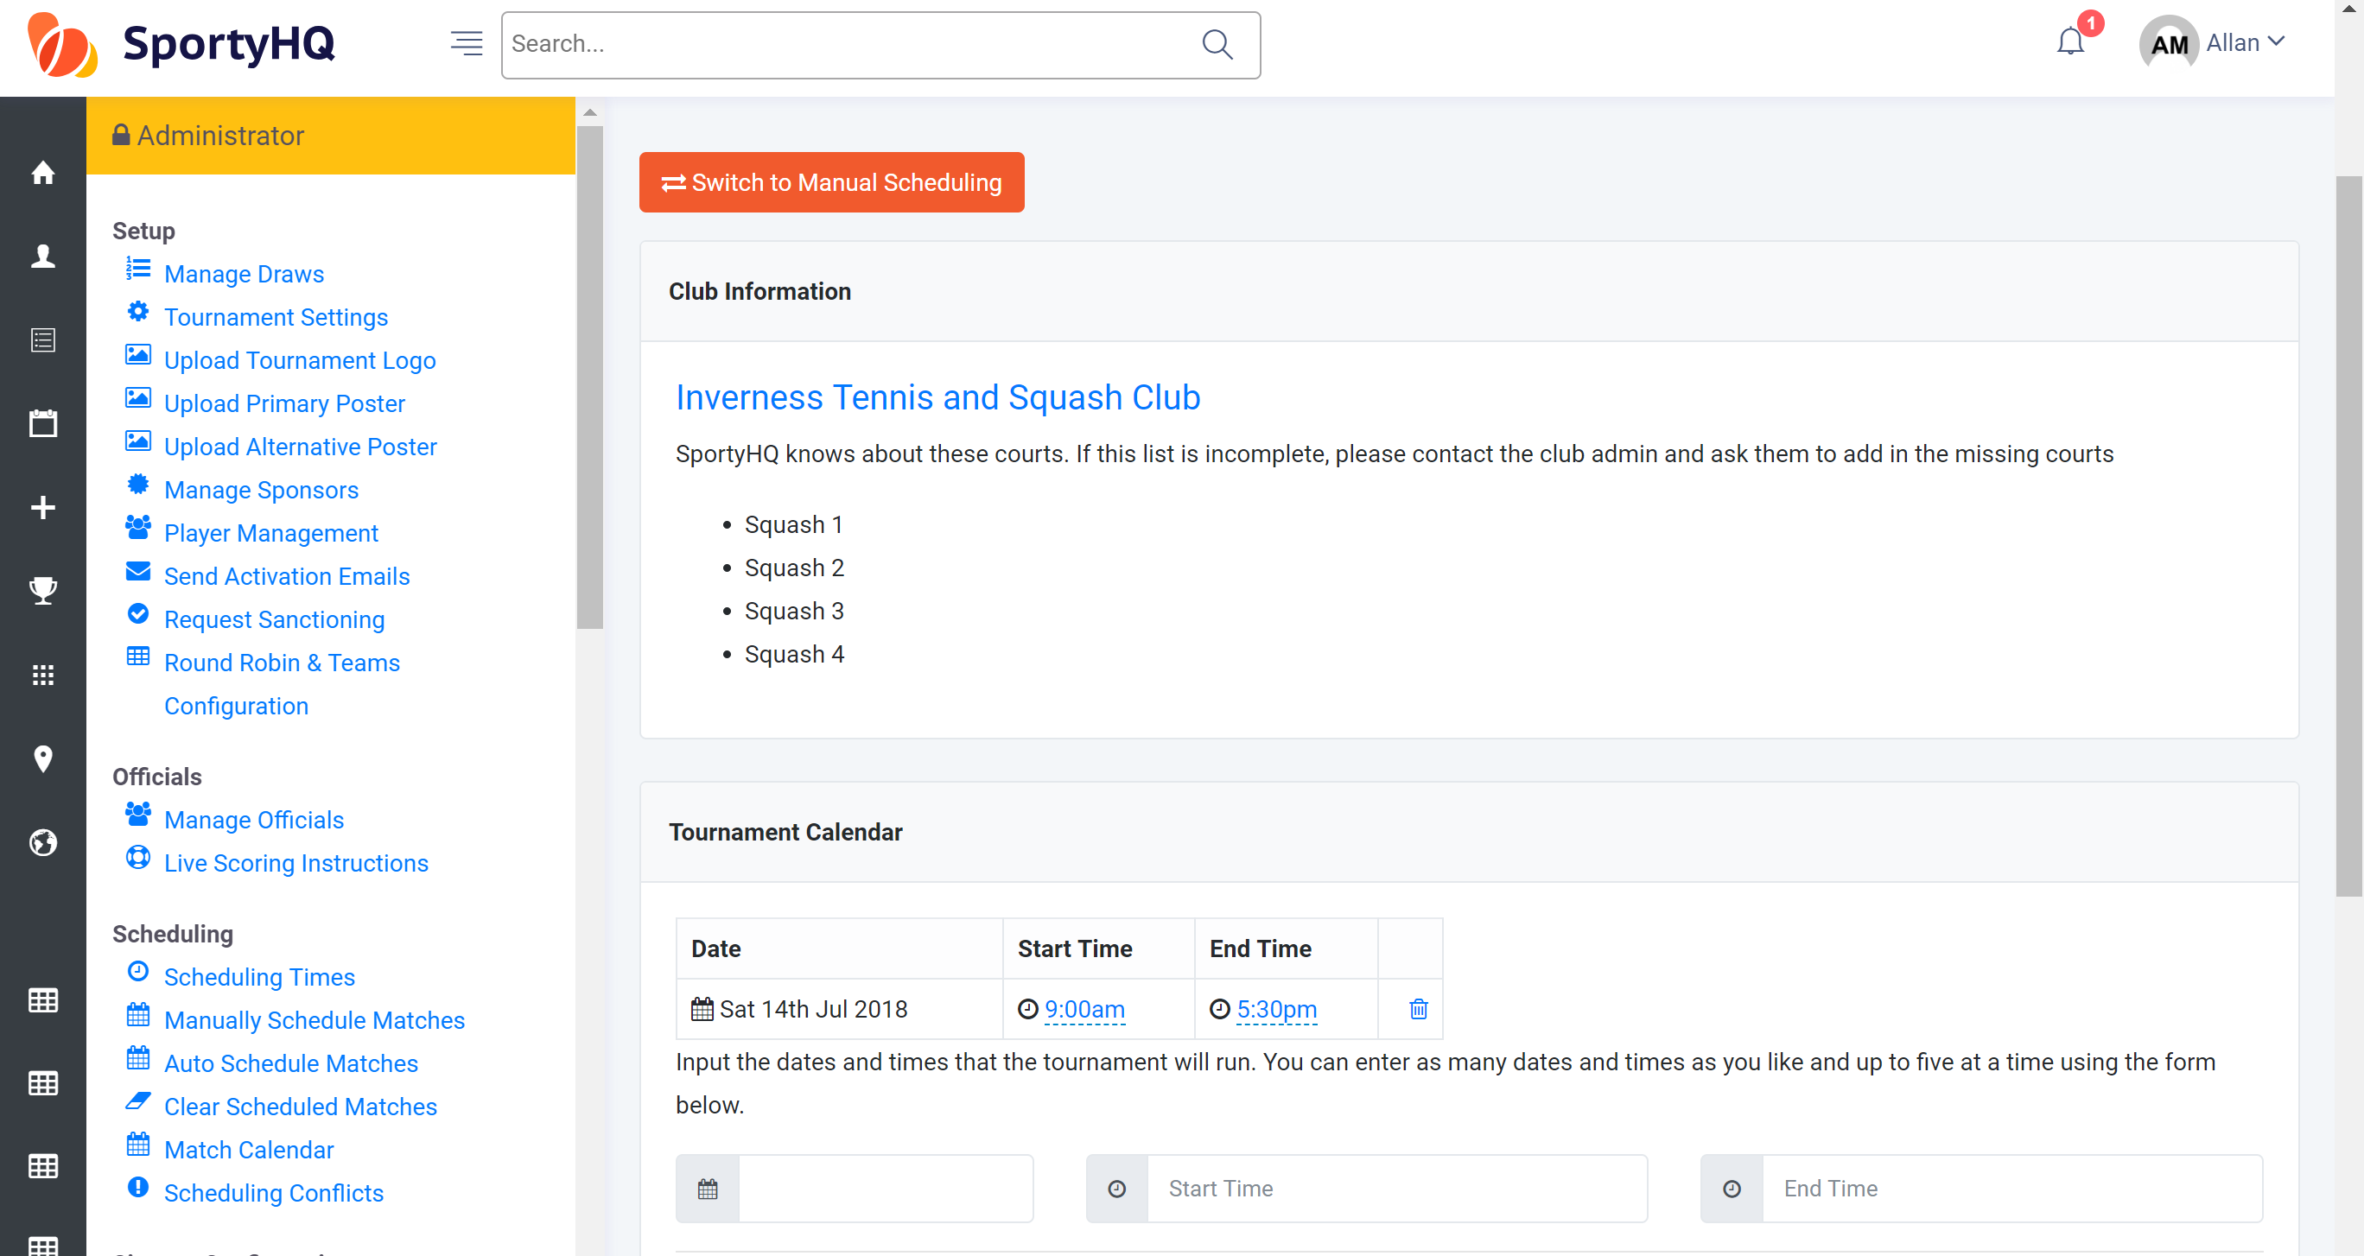
The first box called Club Information will list the courts available in the club that you have selected to run your event from. If this is wrong please contact your administrator for the club.
The section called Tournament Calendar is the section to submit the times you wish your event to start and finish and on the days you wish it to run. You complete this by filling in the area in the blue box above. Then scroll down to the bottom of the page and click Add to Calendar. Once the dates and times have been added they will then appear in the red box shown above.
Click back on the name of your event at the top menu to take you back to the administrator page of the event.
The next stage is to schedule each individual match in all of your draws. We recommend that you use the Auto Schedule Matches function to do this. Click on Auto Schedule Matches and the following window will open.
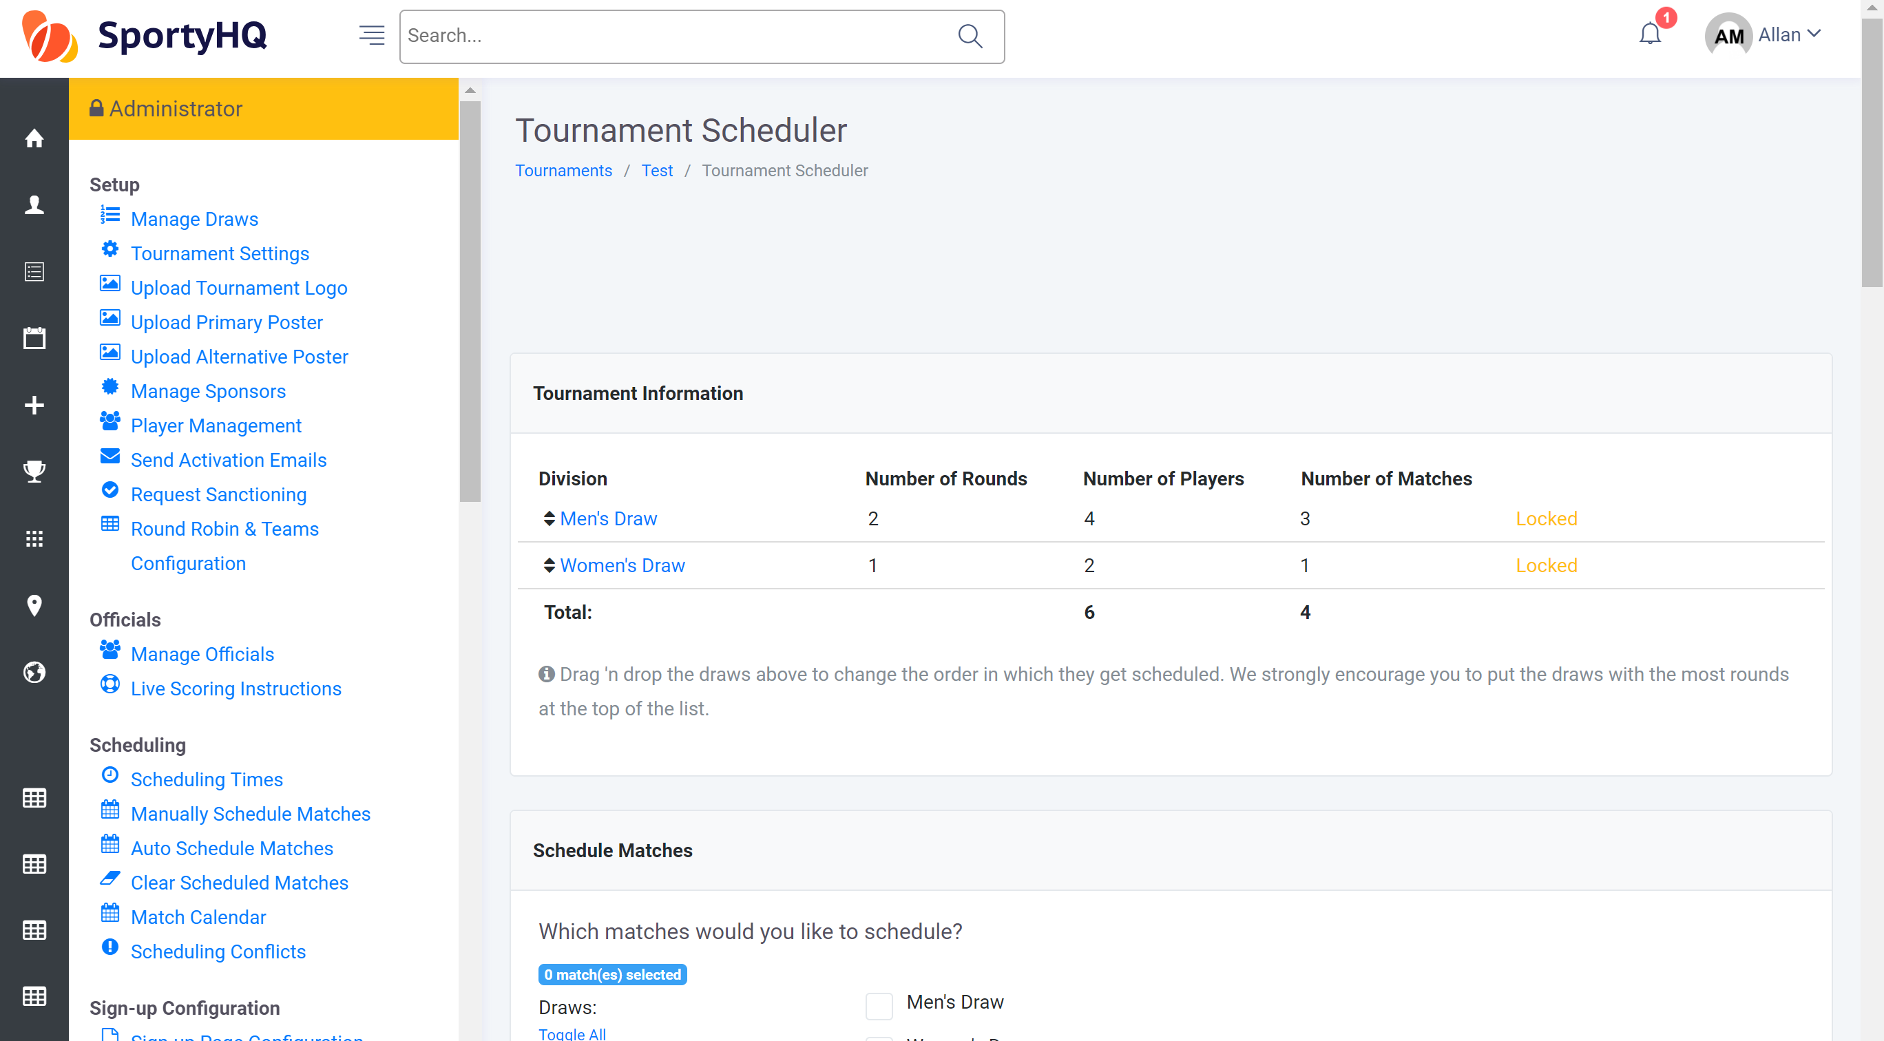
Follow the on-screen instructions to auto schedule the matches in your event. We recommend scheduling each round at a time and making any small changes you may wish to make. Once you have completed the page scroll to the bottom Schedule. If you are scheduling by round click back on Auto Schedule Matches on the administrator panel and follow the same instructions for the other rounds within the competition.

Once you have scheduled your competition you can review the schedule by clicking on Match Calendar. The following window will open.
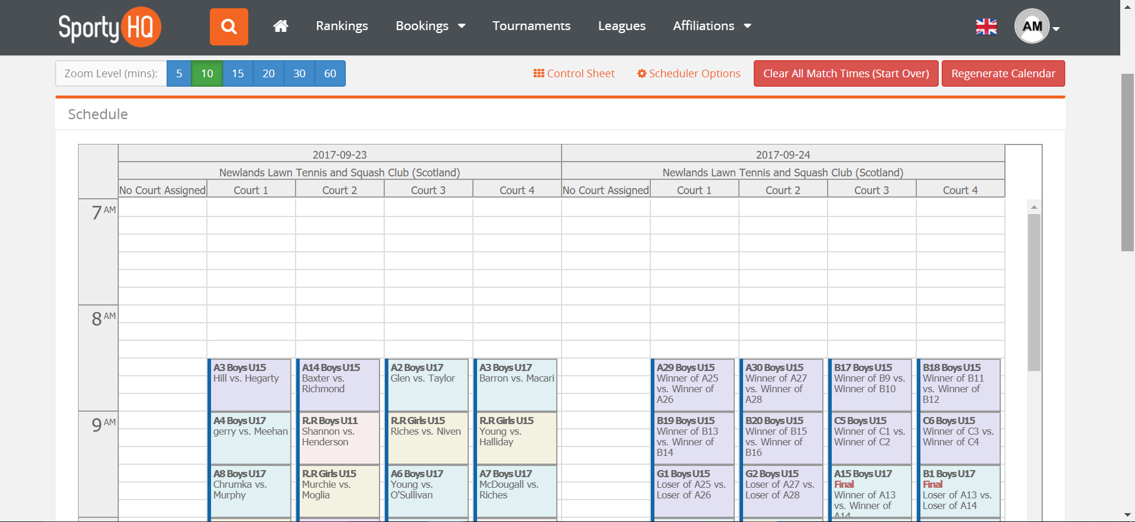
On this page, it shows you all the matches scheduled. You can move any matches around by clicking on one and dragging it to a new location. You may wish this to put finals on a specific court for example.
If you would like to clear the full schedule and start again, click on the red button Clear All Match Times (Start Over) shown above in the blue box.
By clicking on Scheduling Conflicts under the scheduling column shown above it will open a page that highlights any conflicts in your schedule. This will take in to account players that are potentially playing 2 matches at the same time if they are in 2 or more draws. It will also highlight those players who are not getting the specified rest period against matches with you would have set further back in the process.
You also have an option to manually schedule matches. This will allow you to schedule each individual match of your tournament manually if you would prefer. To do this click on Manually Schedule Matches and follow the onscreen instructions.
At this stage, your draws and schedule for your event should now be complete and you are ready to publish the event for players and spectators to see.
To do this scroll down on the main event page to the Draws section. See below.
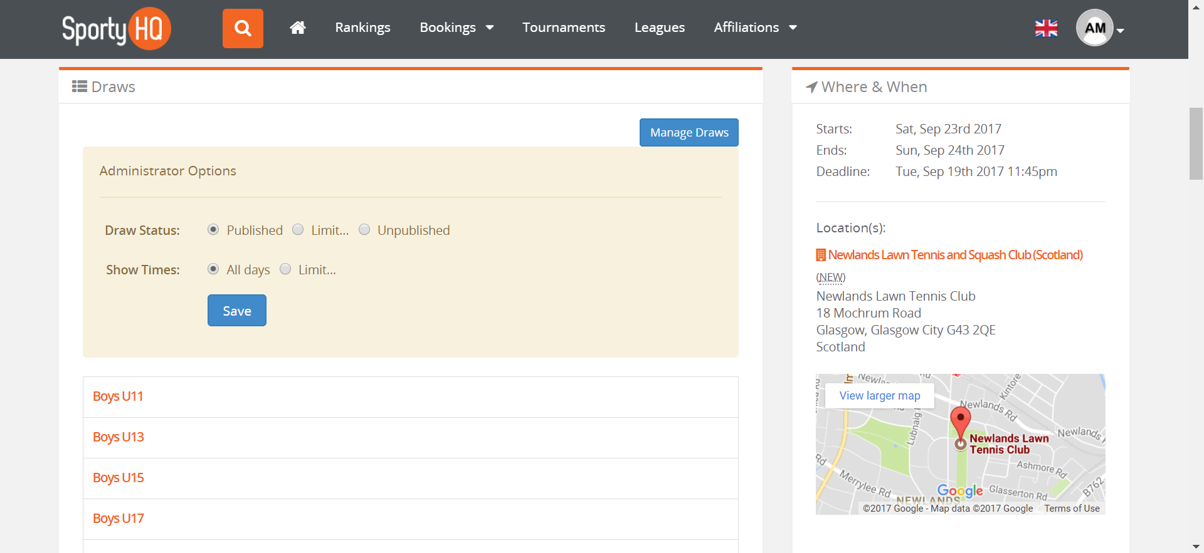
Here you have the options to publish your draws or limit the amount of information you would like to publish. Once this is set click Save. At this stage, your draws and able to be viewed by anyone.
You may wish to e-mail all registered players to make them aware that the draws for the event have been published. To do this refer to section 3. Adding the Extra Detail on page 14.

