Anti Corruption (Sports Betting) Policy

VERSION CONTROL
Version No. | Date | Amended by | Reason
1.0 | 10/6/2014
2.0 | 6 November 2015 | Alan Marshall | Suitability review
3.0 | 21/04/2016 | Compliance Group | Approval

- Introduction

  - Scottish Squash Limited staff has a contractual obligation to maintain the highest standards of integrity by carrying out their work in a way that will not compromise the reputation of the organisation.

  - This policy sets out Scottish Squash Limited’s standards and procedures relating to Anti-Corruption (Sports Betting) and applies to all individuals working for and representing Scottish Squash Limited, which includes Scottish Squash Limited Board members and all employees, contractors, consultants, and/or related personnel of Scottish Squash Limited acting in any capacity or activity sanctioned by Scottish Squash Limited as determined by one of Scottish Squash Limited’s Executive Directors in writing. (referred to collectively as “Staff”).

  - The framework for this policy is based on the Scottish Governing Bodies and Sporting Organisations Sporting Integrity – Guidance Note (attached as Appendix 1).

  - The purpose of this policy is to provide an overview and general advice to all the above people on the issues associated with the integrity of sports betting.

  - This Policy is intended to protect the reputation of sport, Scottish Squash Limited, and each individual acting for it. Please note that responsibility for complying with this policy lies with all those to whom it applies.

- Sporting Integrity

  - A core function of Scottish Squash Limited is to maintain, and be seen to be maintaining the integrity of sport.

  - Scottish Squash Limited must take action to protect itself from the threats posed to its integrity by corrupt betting and associated activity both from within and outside the organisation. As sports betting activity has increased across all sports and disciplines, it is essential that such activity does not take place in a manner which has the potential to compromise sporting conduct and endeavour.

  - There will be stricter rules for members of Staff in positions of trust and/or at particular risk and this will depend on the role of the Staff member.

  - If you are “Directly Involved” with the sport of squash you cannot
    - bet on matches at your level of your affiliation or below. i.e. WPSA players cannot bet on WPSA matches and BPSA cannot bet on BPSA matches;
    - ask someone to bet on your behalf on the sport anywhere in the world;
    - share any “Inside Information” with anyone including but not limited to your spouse, cohabitee or dependant children which could enable them to gain an advantage through corrupt betting activity (See section 4 (Inside Information) for further information); and
    - become involved in any other activity associated with corrupt betting which could reasonably be deemed as suspicious and detrimental to the image and reputation of Scottish Squash Limited and the sport.
    - All directors of SSL are considered to be affiliated at the highest level and therefore paragraphs 2.4.1., 2.4.2, 2.4.3 and 2.4.4 apply l to them whilst they are in office
  - “Directly Involved” means working with a sport as a representative of Scottish Squash Limited.
“Directly Involved” for the purposes of this policy, includes:
- Players (all professional and representative players)
- Referees
- Coaches (all registered coaches)
- Staff (all salaried staff)
- Directors of SSL
  - The following offences are also prohibited:
    - fixing a match or attempting to fix a match;
    - benefiting from failing to perform;
    - soliciting, inducing, encouraging, offering a bribe (or attempting to) any other party to do any of the above offences;
    - receiving, seeking a bribe (or attempting to) in order to fix a match or attempt to fix a match;
    - The offering of inducements/bribes to influence the selection of any individual for any event
    - posing a threat to the integrity of the sport;
    - destruction of evidence in relation to a potential breach; and
    - failing to report suspicions or approaches.

- Criminal offence of cheating
(section 42 of the Gambling Act 2005 refers)

  - Section 42 of The Gambling Act 2005 has created a new offence of “cheating at gambling” which would include cheating in sports influenced by betting involvement (see the extract of section 42 of the Gambling Act 2005 in Appendix 2).

  - Breach of the Gambling Act 2005 new rules may result in the imposition of severe penalties for individuals (fines and jail).

  - Depending on the nature of the activity, Scottish Squash Limited’s Investigation Panel (see section 6.5-6.13) may refer the matter to the Gambling Commission for consideration of an investigation of the criminal offence of cheating at gambling.

- Inside Information

  - The sharing of “Inside Information” by anyone captured by this policy is specifically prohibited by Scottish Squash Limited.
    - “Inside Information” means any information, which is not Publicly Known that would materially affect people’s expectations relating to the participation in, or the likely or actual outcome of a sporting competition or event. Such information includes, but is not limited to, factual information regarding the competitors, the conditions, tactical considerations, injuries, or any other aspect of the sporting competition or event. “
    - Publicly Known” means any information that is already published as a matter of public record, able to be readily acquired by an interested member of the public, or disclosed according to the rules and regulations governing the relevant sporting competition or event.
  - With regard to your responsibilities under 2.4.3, it is your responsibility to determine whether information which you have access to falls under the definition of “Inside information”. You are advised to err on the side of caution. You should also seek advice from Scottish Squash Limited’s Betting Integrity Officer. (see below)
Betting Integrity Officer - Roles and Responsibilities

  - Scottish Squash Limited’s CEO is Scottish Squash Limited’s designated Betting Integrity Officer.

  - All Scottish Squash Limited staff are responsible for betting integrity issues but the Betting Integrity Officer has specific additional responsibilities including:
    - establishing and maintaining a sound Sports Betting Policy that supports the achievement of Scottish Squash Limited’s policies, aims and objectives; and
    - advising the Investigations Panel (see section 6 below).

6. Response Plan

6.1 It is vital that, if there is any suspicious betting activity in Scottish Squash Limited, action is taken.

6.2 All Staff should be aware that they must not try to deal or investigate any allegations of corrupt betting and associated activity by themselves but should immediately report the matter to Scottish Squash Limited’s Betting Integrity Officer.
6.3 All Staff must report any approach or activity which contravenes, or which may contravene this Policy. Specifically,
    - if any member of Staff is approached about fixing any part of a match or asks for “Inside Information” then he/she must report this and cannot just ignore it;
    - if any member of Staff has any concerns about any other member of Staff’s activity then he/she must report this; and
    - any threats should always be reported.
6.4 In the event that a member of Staff is concerned that the Scottish Squash Limited Betting Integrity Officer (CEO) is involved in suspicious betting activity outlined in section 6.3 above, this should be reported to one of Scottish Squash Limited’s Board of Directors.

6.5 All Staff must co-operate with any investigation and/or request for information including the provision of documentation (e.g. telephone/betting records to the Investigations Panel (see section 6.6-6.12 below)

6.6 The Betting Integrity Officer will co-ordinate the investigation and set up an Investigations Panel consisting of not less than three Scottish Squash Limited Staff members including the Betting Integrity Officer. The Investigations Panel will not include any person under investigation or any person reasonably considered to be associated with the person under investigation. In the event that the Betting Integrity Officer is under investigation the Investigations Panel will be appointed by the Scottish Squash Limited board of Directors. It shall be in the option of the Betting Integrity Officer (or of the Board of Directors if they are called upon to appoint the Investigations Panel) to appoint a person independent to Scottish Squash Limited management to chair the Investigation Panel.

6.7 The Investigations Panel will investigate the allegation. A member of the Investigations Panel will be allocated with the responsibility for leading the investigation process.

6.8 The Investigations Panel should establish the facts quickly and any threat of further corrupt betting and associated activity should be removed immediately.

6.9 The Investigations Panel is required to:
    - act promptly in investigating the allegation and taking any action required
    - fully document the investigation process;
    - secure evidence in a manner which does not alert suspects at the outset of the investigation; and
    - ensure that the evidence is secured in a legally admissible form (e.g. evidence must be carefully preserved; it should not be handled and no marks made on original documents; a record should be kept of anyone handling evidence).

6.10 Depending on the nature of the activity, the Investigations Panel may refer the matter to the Gambling Commission for consideration of an investigation of the criminal offence of cheating (section 42 of the Gambling Act 2005). Additionally, the Investigations Panel may wish to liaise with betting operators, European/International federations, the Police and the Sports Betting Group.

6.11 Depending on the nature of the fraud, the Investigations Panel may wish to contact external experts for advice.

6.12 The Investigations Panel must obtain the consent of SMT before contacting any of the third parties referred to in 6.9 and 6.10 above.

6.13 The Investigations Panel will prepare a report of its findings and recommendations to chair of the compliance group for final approval. The report will include details of:
    - recommendations on how to deal with employees under suspicion (which may include action to suspend or dismiss a employee- employees under suspicion who are allowed to remain on the premises must be kept under constant surveillance; carry out an immediate search of the suspects work area, filing cabinets, computer files);
    - recommendations on how to deal with third parties under suspicion;
    - recommendations for mitigating the threat of future corrupt betting and associated activity by taking appropriate action to improve controls;
    - recommendations for disseminating the lessons learned from the experience in cases where there may be implications for the organisation as a whole; and
    - recommendations on what information can be released externally if requested.

6.14 The Investigations Panel should liaise with those in Scottish Squash Limited with media responsibility and inform them precisely of what information can be released if requested. Those with media responsibility should retain a record of what information was released and to whom.
6.15 If a member of Staff feels that his/her concerns have not been dealt with appropriately internally, you should also be aware that you are empowered to take any concerns to the relevant authorities and other associated external bodies including the Gambling Commission, so long as you act in good faith.

7. Scottish Squash Limited Board members
(This is Scottish Squash Limited Board of Directors)

7.1 A separate response plan will be required for Scottish Squash Limited Board of Directors

7.2 As a Scottish Squash Limited Board of Director, if you are concerned that a fellow Board member(s) or any employees of Scottish Squash Limited, including the Chief Executive is involved in suspicious betting activity you should inform the President or the Vice-President if the concern involves the President.

7.3 If a Scottish Squash Limited Board member believes that the issue cannot be considered objectively by any member of the Board of Directors or senior management, BUT ONLY once all attempts to do so have been exhausted they should take their concerns to the Sport Scotland/ Sports Resolution Panel in the first instance. As Scottish Squash Limited Board members are appointed by the membership, concerns that cannot be dealt with internally must be taken to parties empowered to take required action – this may mean taking the matter to the Sport Scotland/ Sports Resolution Panel

7.4 If a Scottish Squash Limited Board member feels that your concerns have not been dealt with appropriately internally or by Sport Scotland/Sports Resolution Panel, you should also be aware that you are empowered to take any concerns to the relevant authorities and other associated external bodies including the Gambling Commission, so long as you act in good faith.

8 Compliance

8.1 This policy will be reviewed annually unless circumstances dictate more frequent reviews.

8.2 Employees who breach this policy and procedure may be subject to disciplinary action.

8.3 Compliance of this policy will be monitored by the Scottish Squash Limited Board of Management.

Appendix 1

Scottish Governing Bodies and Sporting Organisations

Sporting Integrity – Guidance Note

A core function of all Scottish Governing Bodies (“SGBs”) and sporting organisations is to maintain, and be seen to be maintaining, the integrity of their sport. Integrity must be upheld in order to protect the reputation - and the financial and participatory viability - of sport. Sport must take action to protect itself from the threats posed to integrity by corrupt betting and associated activity both from within and outside the sport.
A new era for sport and betting
The relationship between sport and betting has changed profoundly over recent years. The proliferation of online betting (particularly in-play betting), the growth of betting exchanges (where it is possible to “lay to lose”) and an upsurge in the availability of “novelty bets” means betting on sport is more popular and easier than ever before. Betting markets are expanding, particularly when live broadcast coverage is available.
Be prepared
Even if betting is not currently perceived to be an issue in your sport, it is vital that the sport and its participants are protected. Being proactive, rather than reactive, is essential to protect sport before any damage is done. The advice contained within this document offers initial guidance to SGBs and sporting organisations in putting rules and regulations in place and complying with the code of conduct on integrity in sports in relation to betting recommended in the Report of the Sports Betting Integrity Panel published in February 2010.
While this document provides guidance on the minimum standards expected of sporting governing bodies and sporting organisations in putting anti-corruption rules and regulations in place, sporting governing bodies and sporting organisations are encouraged to adopt the highest standard possible in order to reflect the risks to their sport.
There are six actions that each sport’s governing body and sporting organisation go through in order to help safeguard their sport from the threats posed to integrity by betting:

6 Step Action Plan

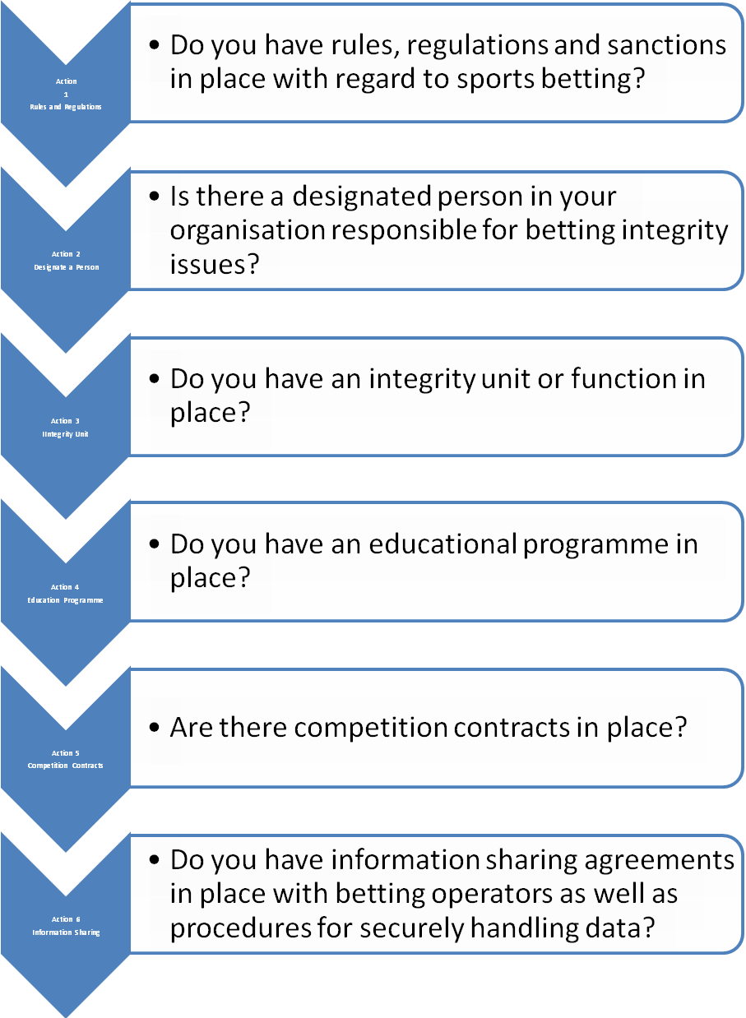
Action 1 Establish Rules and Regulations on Betting
SGBs and sporting organisations must have robust rules and regulations in place that reflect the risks to their sport. The rules must make it clear to participants what is and what is not acceptable in relation to betting. They must also define to whom the rules apply (i.e. who exactly is a ‘participant’?).
SGBs should ensure that they include in their rules and regulations a provision that a participant shall not use in relation to betting any inside information that is not publicly available and which has been obtained by virtue of the participant’s position within the sport, and in this respect SGBs and sporting organisations should within their rules clearly define what is meant by “inside information”. This definition should be specific to the individual sport in question, based upon the risks that have been identified, and sufficiently wide-ranging to cover all perceived eventualities. The rules should also clearly state what can be considered misuse of inside information and the sanctions that can be expected should such rules be breached.
By way of example only, the Gambling Commission uses the following definition of “inside information”: “Inside Information is information relating to the participation in, or the likely or actual outcome or development of, an event which is known by an individual as a result of their role in connection with that event and which is not in the public domain.”
Consultation with participants when developing rules is an important step to producing a framework that is workable in practice and is supported by participants.
Sanctions must be sufficiently robust to act as an effective deterrent while also being proportionate for your particular sport.
The minimum rules identified in the Report of the Sports Betting Integrity Panel into betting integrity are set out below. They oblige a participant to:
• Not place or attempt to place a bet on a match, race or other event or competition in which he or his club participates in
• Not solicit or facilitate, or attempt to solicit or facilitate, another person to bet on a match, race or other event or competition in which he or his club participates in
• Not offer, or attempt to offer, a bribe in order to fix or contrive a result or the progress of a match, race or other event or competition in which he or his club participates in
• Not receive, or seek or attempt to receive, or seek a bribe in order to fix or contrive a result or the progress of a match, race or other event or competition in which he or his club participates in
• Report any approach or other activity which contravenes, or which may contravene, the sport’s rules on betting, co-operate with any investigation and/or request for information including the provision of documentation (e.g. telephone/betting records to officials engaged in the investigation of suspected integrity issues in the sport in relation to betting)
• Perform to the best of his ability in any match, race or other event in which he participates in.

Once rules and regulations are in place, a number of other steps should be considered. Some of these are very simple to introduce, while others are more complex and may only need to be implemented where a significant level of risk is identified.

Action 2 Designate a Responsible Person

All SGBs or sporting organisations should assign responsibility for betting integrity issues to a particular person within their organisation. Depending on the risk to your sport this may be no more than a nominal role, for example checking that your SGB or sporting organisation complies with the basic standards in Report of the Sports Betting Integrity Panel. As and when required, this designated person can liaise with participants, the Gambling Commission, betting operators, European/International federations and the Police.

Action 3 Integrity Unit

If the volume of betting markets in your sport is substantial, or you have identified bets that are easy to corrupt, it is recommended that you consider establishing a dedicated integrity unit. Not all sports will need to set up dedicated integrity units, but those that identify a significant level of risk to integrity from betting should look to do so.

Tennis, Cricket, Horseracing, Snooker and Darts are examples of sports that have established dedicated units. In the case of the British Horseracing Authority, their Integrity Services, Compliance & Licensing Department aims to identify and prevent breaches of the rules and malpractice in horseracing. This is achieved by gathering information, monitoring real-time betting markets for suspicious betting activity, conducting investigations and inspecting training establishments. It is vital that, if there is any suspicious betting activity on your sport, action is taken.

If there is reluctance on the part of the Gambling Commission or the Police to become involved, then the SGB or sporting organisation should take action by fully investigating any allegation. If it does not have the resources to carry out an investigation they should consider requesting outside assistance.

Action 4 Educational Programme

It is essential that participants are fully aware of the relevant rules and regulations in their sport and in this respect participant education has a major part to play when it comes to minimising the risks to integrity posed by betting. It is recommended that, as part of your standard training programmes, you include a section on betting integrity. If you consider your sport to be at significant risk, it is recommended that you run dedicated education programmes.

These can come in a variety of different forms but should provide face-to-face education alongside other mediums such as explanatory notes, online training, posters, cards and brochures. For example, the British Horseracing Authority, Professional Cricketers Association and Professional Footballers Association each have relevant education programmes on sports betting integrity.

Another document that may be useful is the EU Athletes Code of Conduct on Sports Betting for Players, which sets out the guiding principles and provides general advice to all throughout Europe on the issues surrounding the integrity of sport and betting.

Finally, the section on education in the Report of the Sports Betting Integrity Panel contains a number of recommendations on what SGBs should consider in relation to participant education.

Action 5 Competition Contracts

For those taking part in competitions there should be a requirement to sign contracts beforehand which clearly spell out their obligations with regard to betting. For example, at the 2011 British Golf Open all players and caddies were required by the R&A to sign an agreement pledging their compliance with all the PGA European Tour’s Anti-Gaming polices.

Action 6 Information Sharing and Data Handling

If bets are taken on your sport, as a minimum the Gambling Commission and betting operators should know whom to contact in your organisation should suspicious betting patterns be discovered.

SGBs and sporting organisations must also have systems in place to be able to securely handle sensitive data. It may also be necessary to establish information sharing agreements and Memoranda of Understanding with betting organisations such as the Association of British Bookmakers (ABB) and betting exchanges such as Betfair and Betdaq. (This list is not exhaustive)

Appendix 2
Section 42 – Gambling Act 2005

42 Cheating

(1) A person commits an offence if he—
(a) cheats at gambling, or
(b) does anything for the purpose of enabling or assisting another person to cheat at gambling.
(2) For the purposes of subsection (1) it is immaterial whether a person who cheats—
(a) improves his chances of winning anything, or
(b) wins anything.
(3) Without prejudice to the generality of subsection (1) cheating at gambling may, in particular, consist of actual or attempted deception or interference in connection with—
(a) the process by which gambling is conducted, or
(b) a real or virtual game, race or other event or process to which gambling relates.
(4) A person guilty of an offence under this section shall be liable—
(a) on conviction on indictment, to imprisonment for a term not exceeding two years, to a fine or to both, or
(b) on summary conviction, to imprisonment for a term not exceeding 51 weeks, to a fine not exceeding the statutory maximum or to both.
(5) In the application of subsection (4) to Scotland the reference to 51 weeks shall have effect as a reference to six months.
(6) Section 17 of the Gaming Act 1845 (c. 109) (winning by cheating) shall cease to have effect.

